1. **Description of the Problem**

Background of the System

**Doric Engineering Pvt**. **Ltd** is a well renowned private company. It is situated in the 91/B, Elephant Road Boro Moghbazar, Dhaka-1217. It sells a profitable number of generators per week. It started as a small private company three years ago. But due to their supply of better quality generators, their number of customers gradually increased.

Currently the company is using a **manual record keeping system** along with two managers, three cashiers and six salesmen only in the sales department. The customer comes to the company’s office and talks with one of the salesmen. The salesman then chooses a set of **generators**, according to the customer’s requirements, and provides them, with full details, to the customer. Then according to the customer’s choice, a generator is chosen and thus, purchased.

The company stays open between Sunday to Thursday from 8 A.M. to 6 P.M. and on Saturday 9 A.M. to 5 P.M. It remains closed on Fridays.

But as the number of customers rapidly increased over the years, I began to suspect a problem that Doric Engineering might start to face- the **drawbacks of the manual record keeping system.**

My Involvement with the Problem

My father is the Chairman of the Doric Engineering Pvt. Ltd. When I visited his office, I was expecting to observe how their recent transactions were taking place and what I saw was something that might be harmful for the company's growth. The ratio of the number of customer to the number of salesman was 5 to 1. The salesman delayed to give proper attention to each customer. Plus, for each customer he had to personally check the **stock** **register** of the system over and over, as it was a manual record keeping. The customer had to wait to make the transactions and when they reached the cashiers, the drawbacks of the manual system started to show again as the bill was made manually, thus slowly. To top it off, the managers were too busy editing the **stock register**. The number of customer was overwhelming and their face expressions gave a feedback of the **manual record keeping system** being was less than satisfactory.

When I inquired about these problems to my father, he seemed to be agreeing with me of searching for a proper solution. I took my chance and asked if I could solve their problem by introducing a computerized database system. Fortunately the Managing Director was present and the decision was made of introducing the computerized database system.

Fact Finding: Method 1 - Interview (Fig: 1.01)

I decided to host an interview with the two managers of the sales department to have a further grasp of the problem being faced and the reasons behind them.

**Interview with the two managers**

1. The method of transaction being used right now, were you aware of its drawbacks?

Ans: Yes, unfortunately we were fully aware of its drawbacks.

1. Have you tried to introduce any sort of alternative method to the transaction system?

Ans: Yes, we have already tried to change some aspects of the method of transaction but it did not seem to help solve the main problems.

1. the owners of the company have decided to solve the current problems by using a computerized database, are you happy about their decision?

Ans: Yes, of course. I am completely agreeing on their decision of using a computerized database system as it may be one of the only efficient solutions to our problems.

1. Are the staff trained enough to handle a computerized database system?

Ans: No, eighty percent of the sales department staff is not trained to use a computerized database system.

1. Do you think a security system is required for the new software that is about to be used in the company?

Ans: Yes, I absolutely think a security system is required to access the database so that data integrity is maintained.

1. Do you have any suggestions or personal choices in the matter of the design of the new software?

Ans: No, I do not have any specific suggestions in the matter of the design of the software, but I only want the software to be user friendly.

My opinion after the interview: The transaction, stock and searching system requires an implementation of a computerized database that would allow easier data manipulation, storage and searching within a short time.

Fact Finding: Method 2 – Observation of the Existing Solution

I observed how the transaction is managed by the staff. And also how the stock and customer registers are managed. And also studied how the invoices and reports are prepared. According to my observation the staffs were facing various obstacles in managing the stock registers as well as the transactions. The manual system seems to have hindered the work efficiency of the company staff. Thus, a new solution was required.

Problem Identification

Later on, some specific customers and staff member, present at that time, were chosen for a short interview and just as predicted the main drawbacks of the manual database system came to light.

* **Maintaining the data keeping is very problematic**

As the system is manual, records are kept in the register by writing which can become lengthy and time consuming. If photocopies are kept every day, for each transaction, then a good amount of cost would be required.

* **Data Integrity is not ensured**

As the database is manual, anyone can get access to them as thus data integrity is lost.

* **Frequent update problem**

The records need to be updated frequently for every purchase of generators. It becomes a very hard task for the staffs to update the records so frequently.

* **Unclear handwriting**

The handwriting of the staff can sometimes be unclear which can lead to dangerous misunderstandings.

* **Transposition and transcription error**

These are errors that are likely to occur while creating or copying records. For instance, someone can read 96 as 69 and accidentally write this number instead.

* **Errors while calculating**

In rush hours calculation mistake may occur as it is done manually using calculators. The cashier can accidentally type 6 as 5 or may be * as +.

* **Finding records**

If the record of a specific product is required, then it becomes extremely difficult to find that record in the database.

* **Field Omission**

The staff can accidentally skip one or more than one of the fields unintentionally.

All of these problems will be solved in the introduction of the new system due to the use of validation and verification. It will be computerized thus handwriting problems, calculation problems, field omission problems and transposition and transcription errors, etc. can be avoided. Finding records will become easier. The database will become easy to update and data integrity will be maintained.

1. **Objectives**

Computerized Objectives

1. **User interface**: The interface of the computerized system should be user friendly so that it is easier to use, by using navigation tools, drop-down lists, etc.
2. **Data storage**: Huge Data should be stored in an orderly manner in separate tables for transaction, customer, etc.
3. **Avoid data duplication and redundancy**: Data will not be duplicated and data redundancy must be avoided by the use of product key, relationship between primary key & foreign key, as a result consistency of data will be increased, like Customer ID used in Transaction table.
4. **Auto ID Generation**: To make the records in the table unique, like Transaction ID, Customer ID.
5. **Validation:** There should be validation and verification checks to reduce the errors in data.
6. **Search & Reports**: The new system should provide faster data searching and faster data reports with much less human intervention.
7. **Security**: There should be a security system to prevent unauthorized people from viewing confidential data.

Business Objectives

1. **Reduces paper cost**: The new system should reduce the extreme paper cost to a minimum.
2. **Reduces** **number** **of** **employees**: The number of employees required for this system is less.
3. **Calculations**: The calculations should be more accurate to prevent the miscalculation of money.
4. **Implementation**: The implementation should be chosen very carefully because if it hampers the transactions then the business can face problems.
5. **Maintenance**: Maintenance should be less time consuming and it should not hamper the process for transactions.
6. **Increase** **efficiency** **of** **staff**: Staff should be able to operate efficiently while in sync with the computerized system.
7. **Increase** **goodwill**: Customer satisfaction increase is also necessary.
8. **Description of existing solution**

Full description of the current system

Doric Engineering Pvt. Ltd is currently using a manual database system. There are two managers, three cashiers and six salesmen only in the sales department. The customer comes to the company’s office and talks with one of the salesmen. The salesman then chooses a set of generators, according to the customer’s requirements and provides them, with full details, to the customer. Then according to the customer’s choice, a generator is chosen and thus, purchased and **provide customer form (Fig: 1.02)**

This is the outside view and it seems pretty easy for the staff. But inside, the company is falling into a jeopardizing situation. The records of transactions, customers and generators are all hand written and stored in manual **registers.** Editing any errors or adding any extra information becomes very difficult. The staff also does jobs of record maintenance, updating, sorting, deleting, making calculations, etc. But there is also the job of searching which is the most fearful one. Because, searching and finding data during transaction, in a company such as this, becomes next to impossible when the data registers are not completely updated or wrongly updated due to human errors. And while editing, all the previous information including the new information is added again to a new page which also consumes a lot of time.

At the end of each day one managers checks the amount of transaction, the number of targets met, etc. And the other manager checks the stock of generators to see if stock re-order is needed. Before leaving, the two managers conduct a meeting with the owner about the transactions, stock, new products, etc.

Process of data input of the Transaction Register (Fig: 1.01)

|  |  |  |  |  |
| --- | --- | --- | --- | --- |
| Sales No. | Date | Generator No. | Name | Address |
| 539 | 18/09/2011 | 103 | Develpoment-2000 Ltd. | Pallabi Extension Dhaka 1216 |
| 540 | 18/09/2011 | 115 | City Lifts Pvt. Limited | Fakirapul, Dhaka |
| 541 | 19/09/2011 | 129 | Square Hospital | Dhanmondi-27, Dhaka |

Process of data input of the Customer Register (Fig: 1.03)

|  |  |  |  |
| --- | --- | --- | --- |
| Name | Address | Contact Number | Bank Name |
| Develpoment-2000 Ltd. | Pallabi Extension Dhaka 1216 | 01813351868 | EXIM |
| City Lifts Pvt. Limited | Fakirapul, Dhaka | 01714489677 | BRAC |
| Square Hospital | Dhanmondi-27, Dhaka | 01846686135 | SOUTH EAST |

Process of bill invoice (Fig: 1.04)

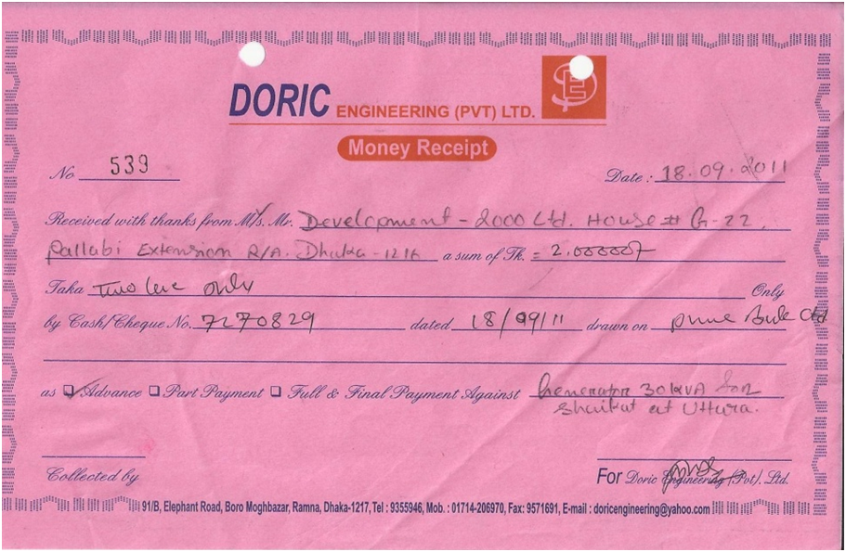

System flowchart of existing system (Fig: 1.05)

A system flowchart of the existing manual record keeping system:

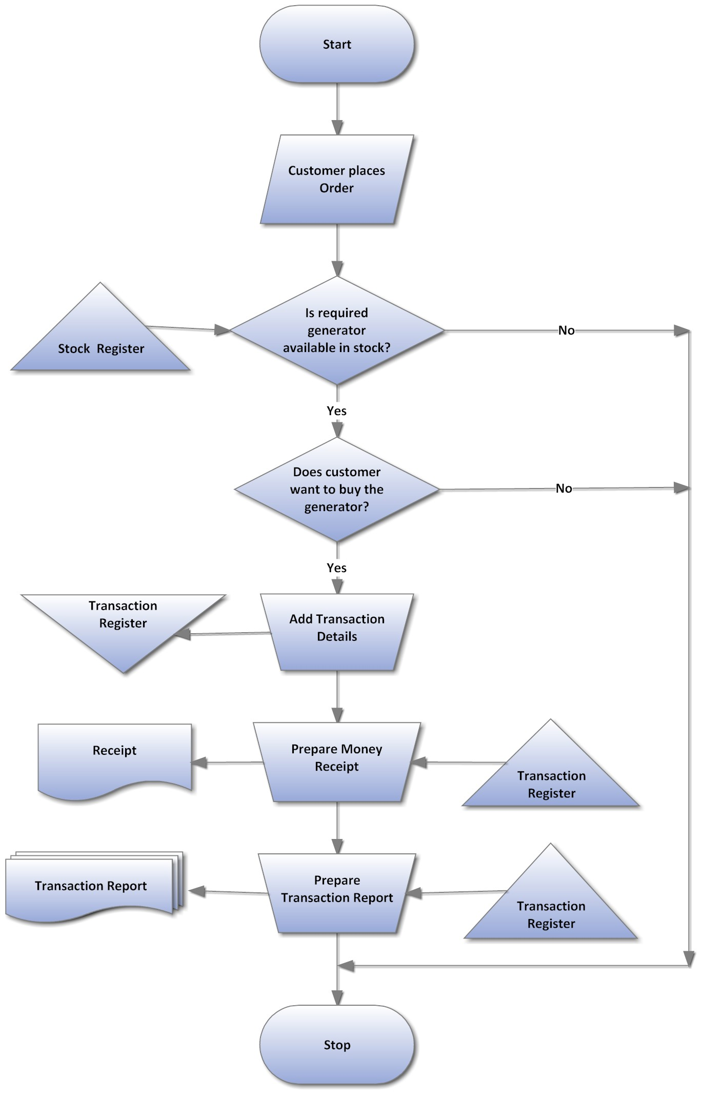

1. **Evaluation of Existing System**

The advantages of the existing system are the following:

* Special training is not required for the staff.
* It is quite efficient when the customer demand is less.
* The structure of the system can be changed very easily.

The disadvantages of the existing system are the following:

* The running and staff cost is very high.
* The speed of customer service reduces along with the increase in the number of customers.
* Data security is almost negligible.
* The data may contain errors as there is no validation system.
* Keeping back up is more costly as it means doubling the amount of materials used for storing data.

Suggested Improvements:

The existing system can be only improved in small-scale because the size of the business does not allow it to increase the fixed factors. The only way to increase possible efficiency is by increasing the variable factors because fixed factors are not variable in short run. The business may decrease the registers and reduce data input requirements, which however may lead to data inadequacy. Data input process can be done by creating a Customer information form, where the customer him/herself fills the data. This may save time of asking questions by the staff to the customer but at the same time, the staff has to input the acquired data into the register. Still this may create a change of data validation as the staff can now make corrections.

These possible improvements may slightly change the efficiency in the short run but in the long run permanent solutions are needed. The cost for system operation and running may increase or decrease if improvements are made. Plus, there is no guarantee that the system will become more efficient.

1. **Description of other possible Solutions**

The following are the description of the other possible solutions:

* Increasing the number of staff members: Increasing more staff might be less time consuming and it may solve the problem of delayed service and update but it increases the cost spent on the staff.
* Enlarging the size of the business: Enlarging the size of the business is very much time consuming and it depends on the how well the business is proceeding. Thus, it is not a reliable solution to the problem.
* Data collection using the customer, staff and a computerized system: This method of implementation is the most costly and most time consuming as new forms are needed to be introduced and the customer has to fill up a form as well which is time consuming.
* A completely computerized transaction, customer and stock recording system: Although it takes more time and is a bit more costly, it allows the data to become flawless through validation. It reduces the number of staff needed and updating it is much faster.

Justification of the choice of the proposed system

The existing system can be improved in many ways but, for the betterment of the business the computerized system, though has some starting costs, is able to fulfill the objectives that a company requires in its long run. As it will use electronic databases to store data, the data will be more validated. Data search and report will become easier. The other proposed solutions may improve the system in the short run but will not be able to improve for a run in the long terms. They will cost more and at the end of the day, will be less efficient than the computerized system. The other proposed systems, but the computerized one, will face problems in storing and manipulating and above all searching for data. So, the computerized system is decided to be the solution for the company’s database system. 

**6. Action plan**

Detailed Description of Action Plan

I will create an Action Plan for the implementation of my generator management system which includes the following:

* Creating Time Line with Starting and Finishing Date
* Creating a Gantt Chart with all the activities
* Designing a Structured Diagram to show the tasks

I will create the system flowcharts for

* Overall System
* Adding a record
* Deleting a record
* Saving a record
* Editing a record
* Searching a record (Co.5)

I will design the following Input and Output layout for my System (Co.1)

* Security (Login Form) (Co.6)
* Main Form
* Transaction Form
* Customer Form
* Generator Form
* Search & Report Form (Co.5)

I will design Navigation for

* Forms
* Records

I will design a File Suture for Smooth Handling of Data.

I will create a Test Strategy for Testing the System. (Co.4)

I will store the data in a Computerized Database. (Co.2)

I will create an ERD for making relationship between the Data Tables. (Co.3)

I used the following formulas for automatic calculations

Gantt Chart + Time Schedule (Fig 2.01)

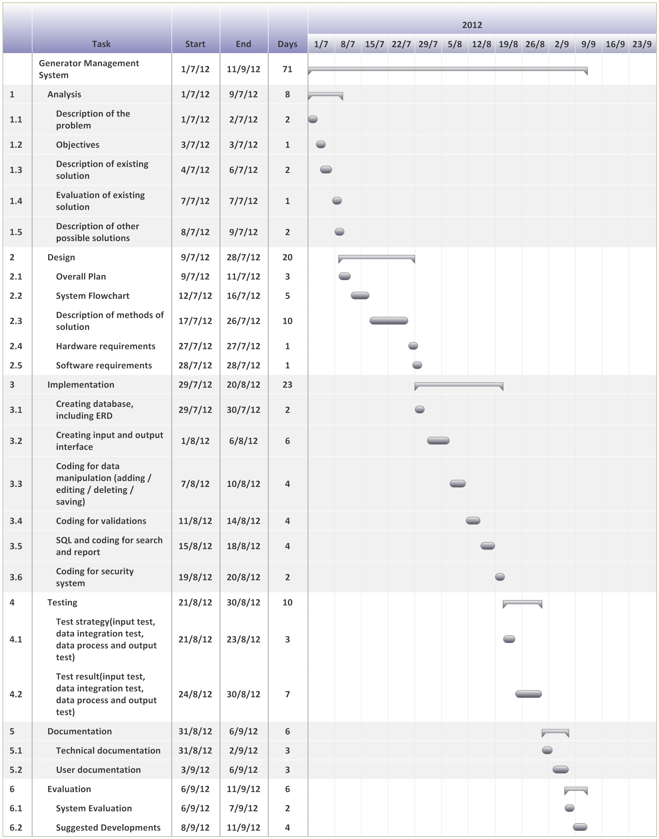

**7. System Flowchart**

System flowchart (Fig 2.02) is used to illustrate how the processes are inter-linked to the data storage. It is used to show the logical designs of an entire system. It shows how data input, process and output is given.

Overall System Flowchart (Fig 2.02)

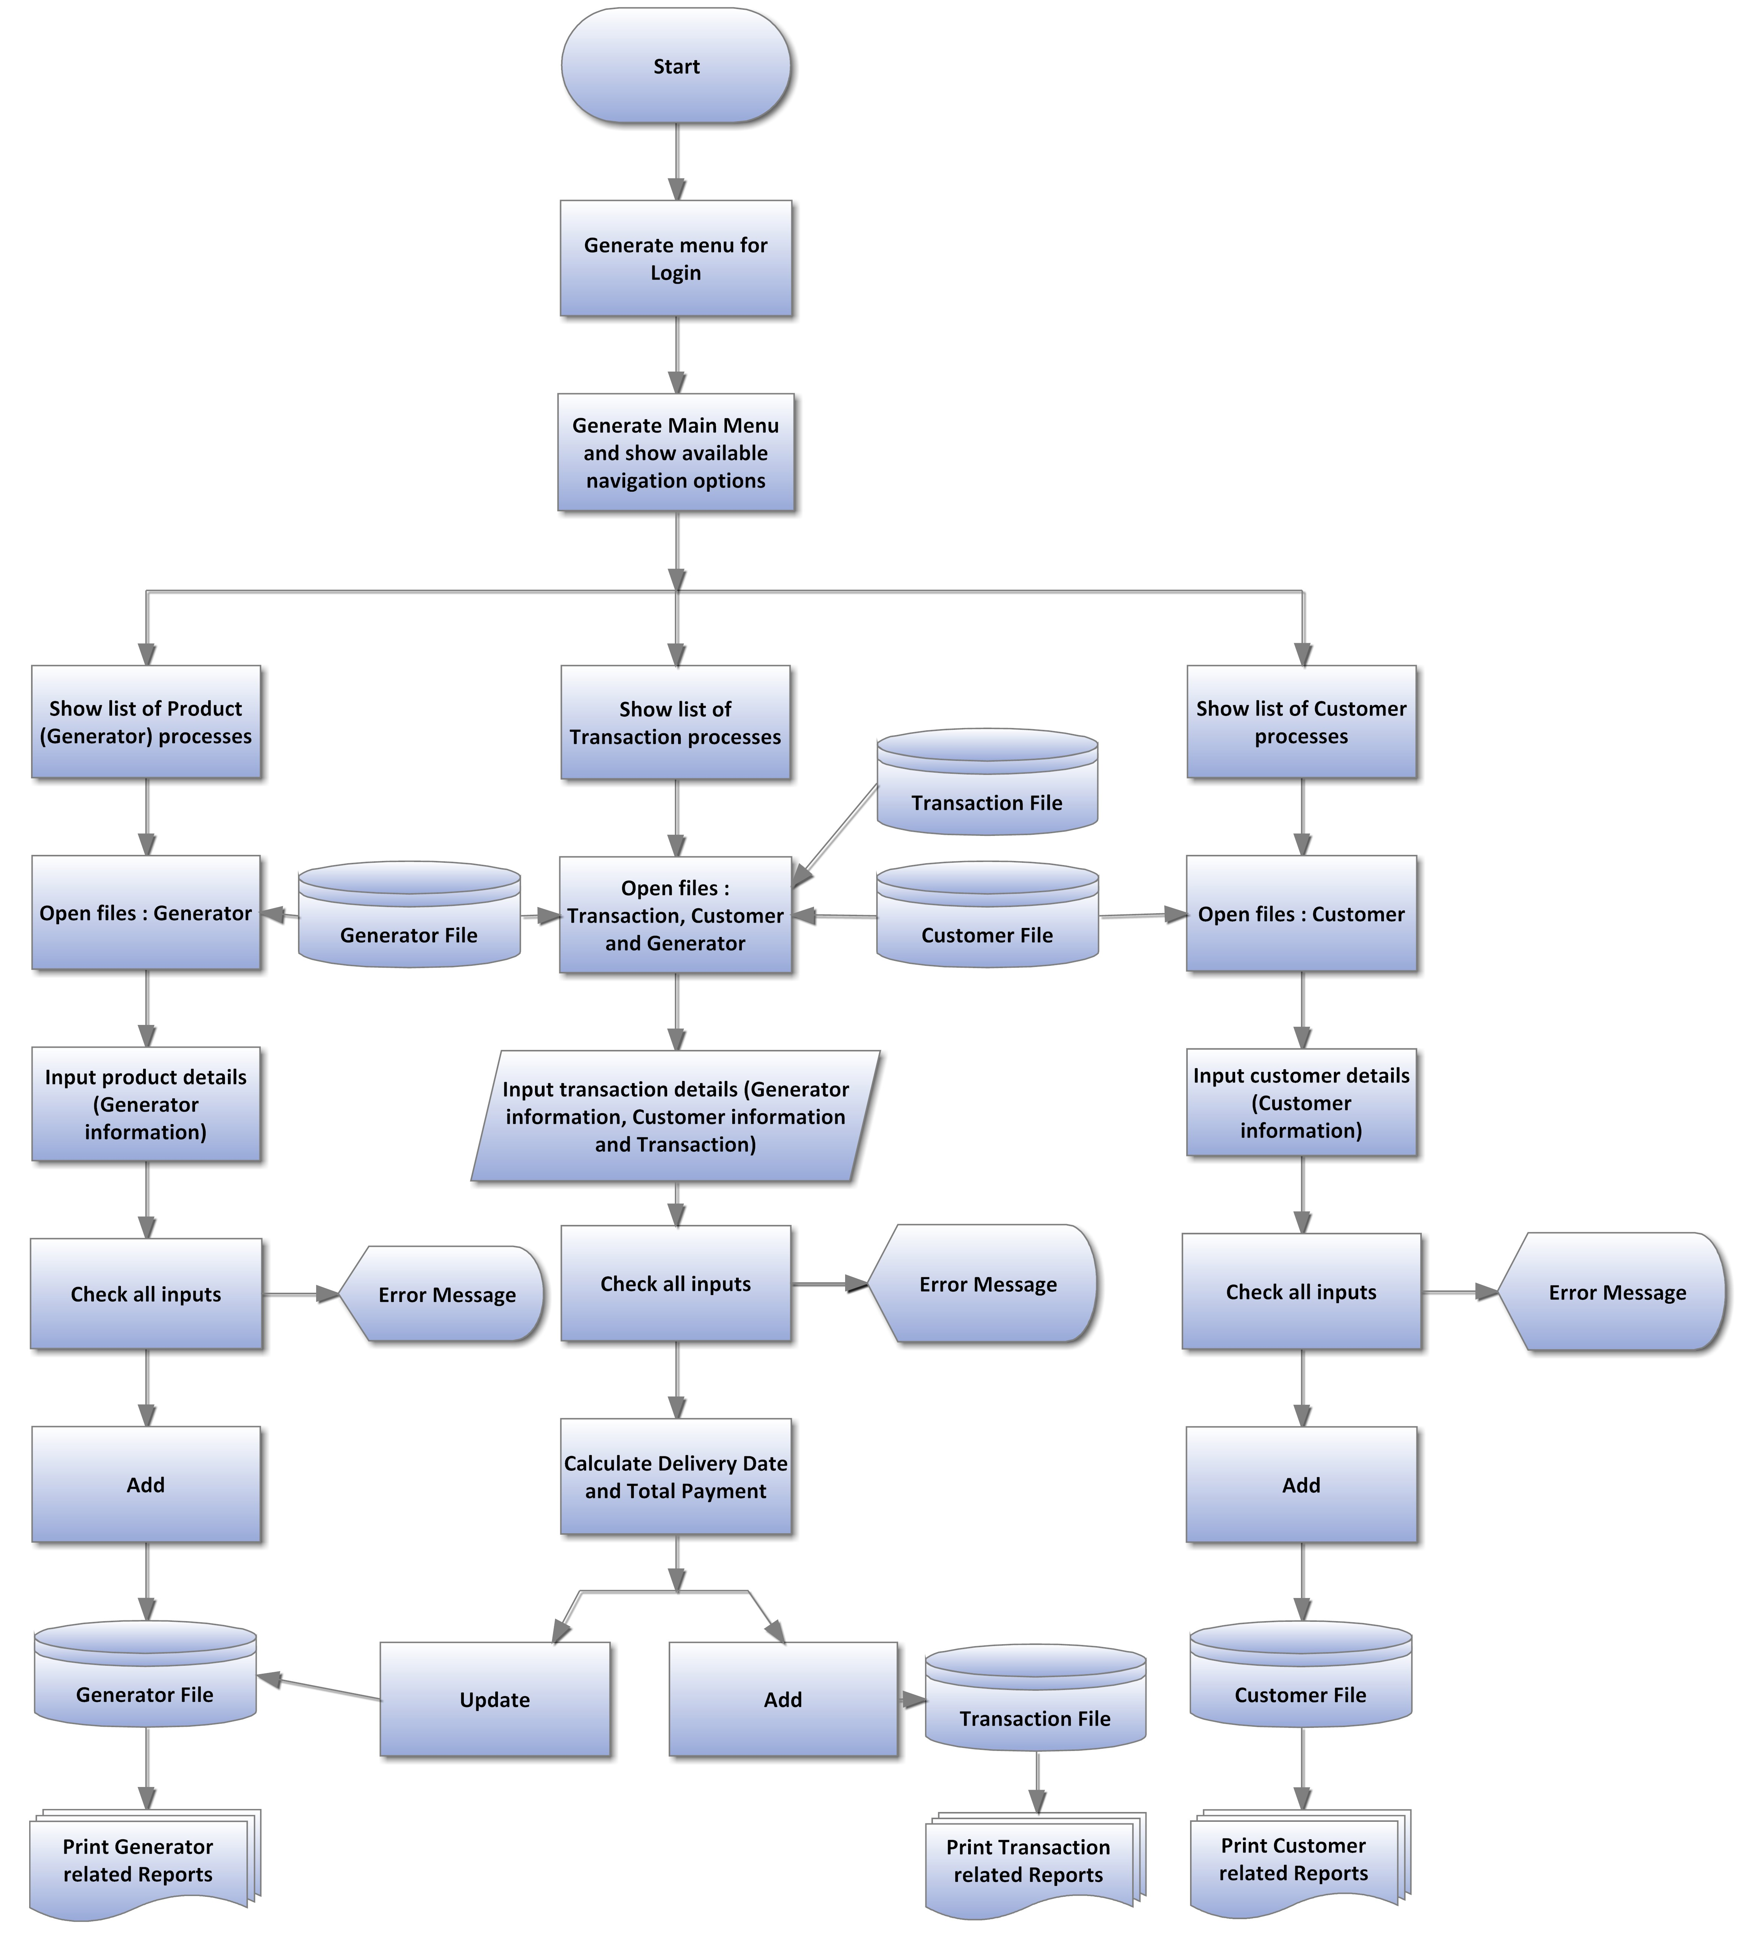

**8. Description of the method of solution**

Top-down design of the new system (Fig 2.03):

To show a helicopter view of the new system and its processes

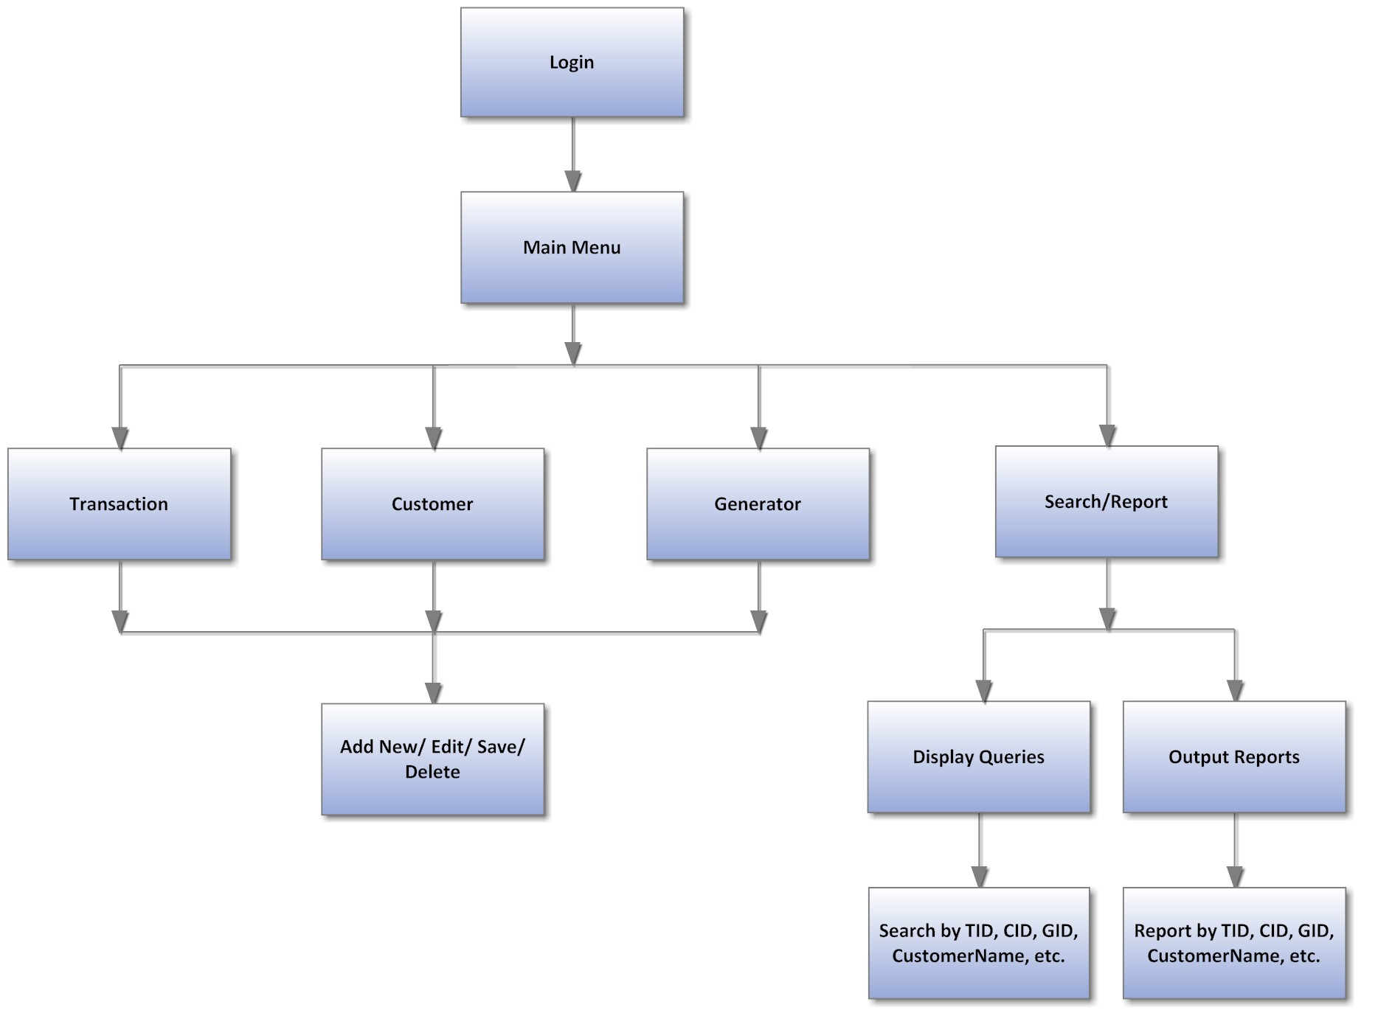

Other flowcharts for different processes:

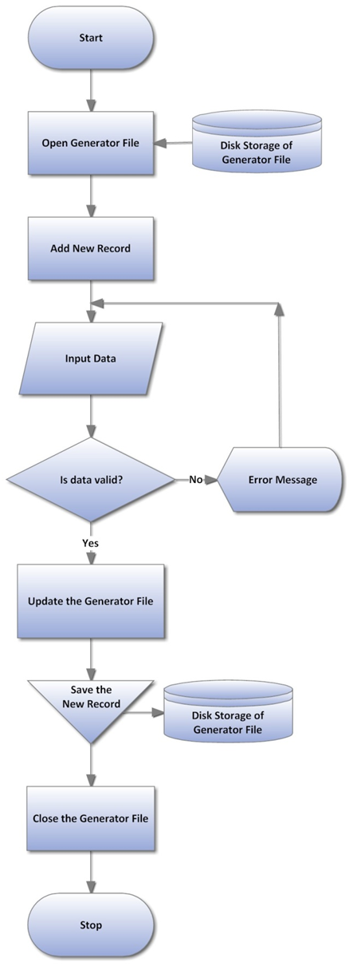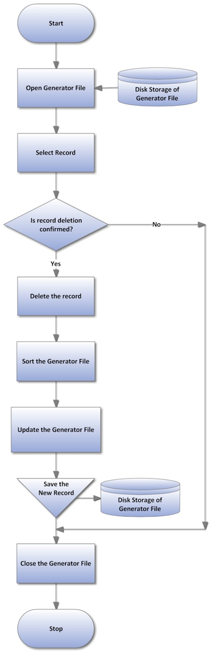

Fig 2.04: Adding a New Record in Generator Table

Fig 2.05: Deleting a Record in Generator Table

Fig 2.06: Editing a Record in Generator Table

Fig 2.07: Searching a Record in Generator Table

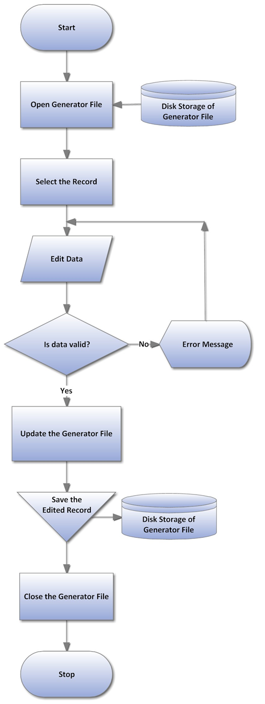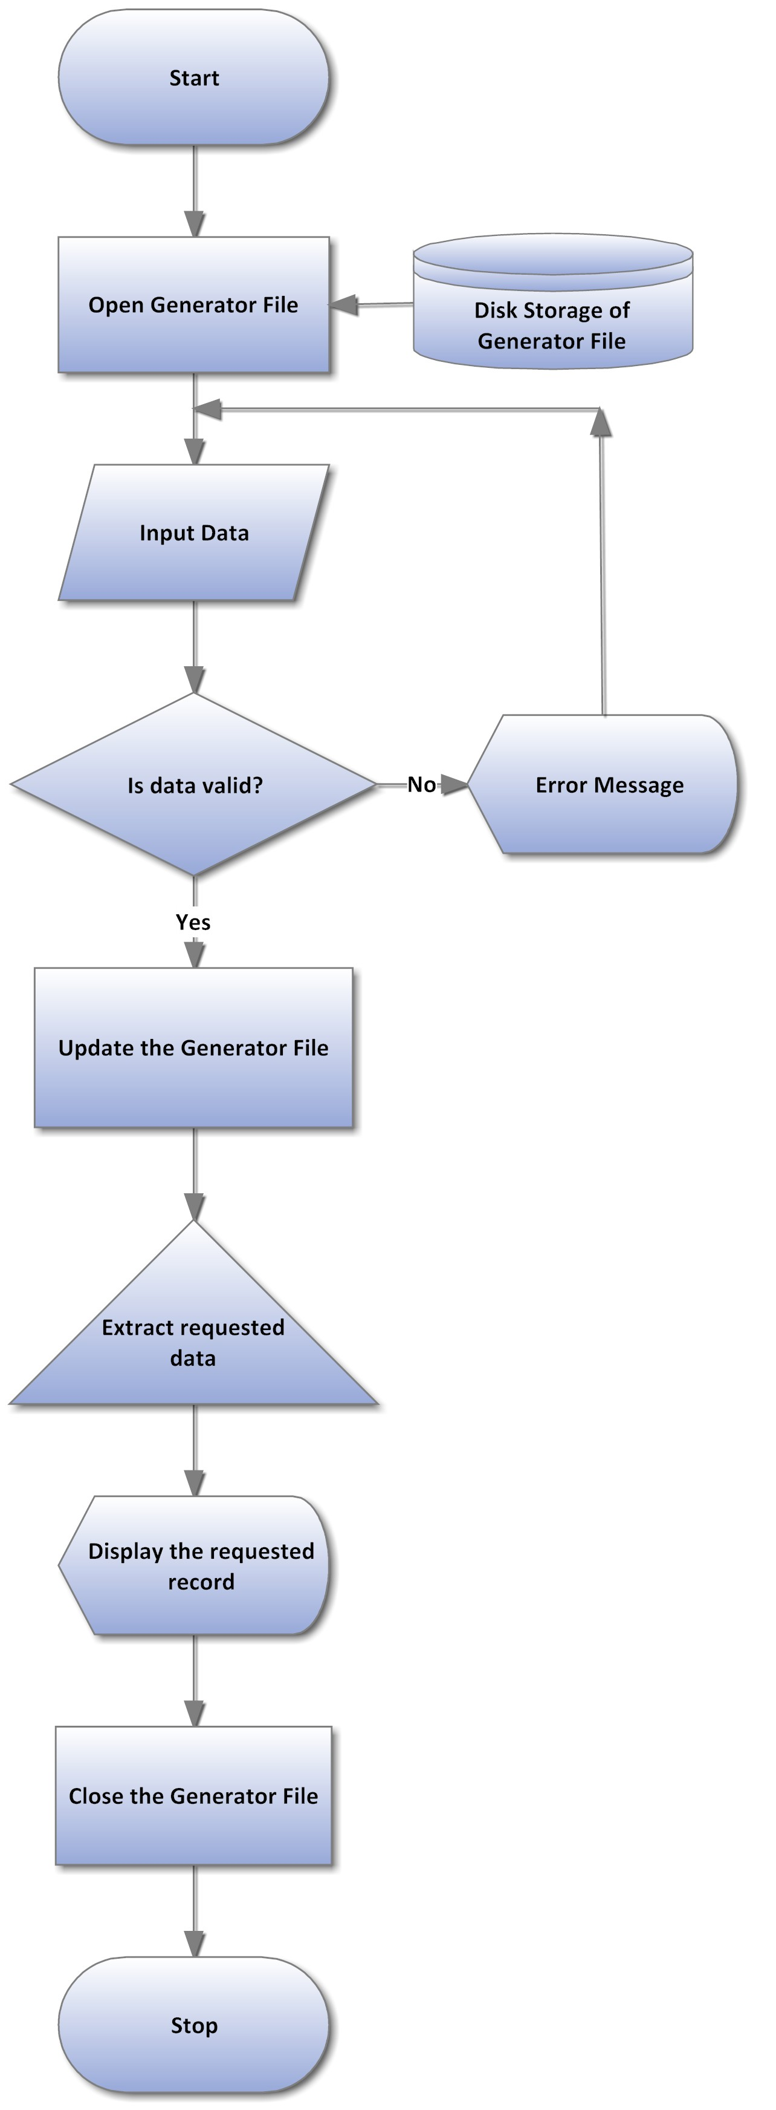

Fig 2.08: Saving a Record in the Generator Table

Fig 2.09: Transaction Processing

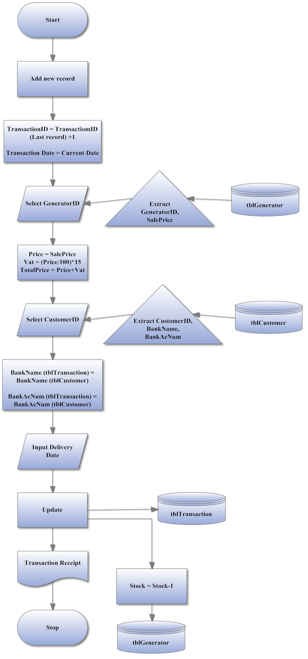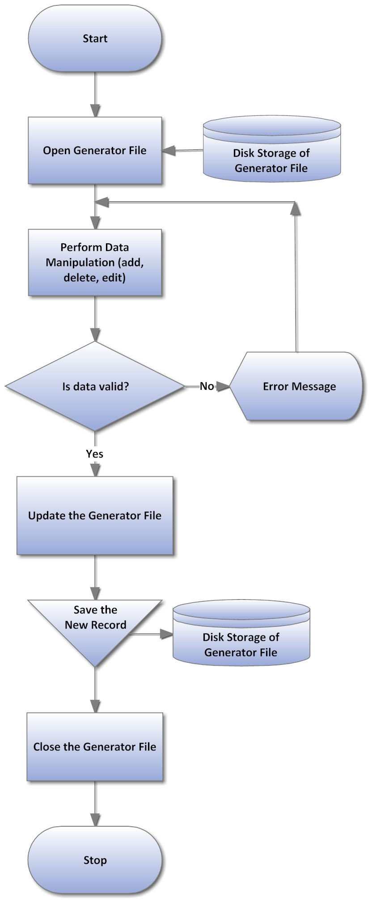

Input Layout of the Transaction Form (Fig 2.10)

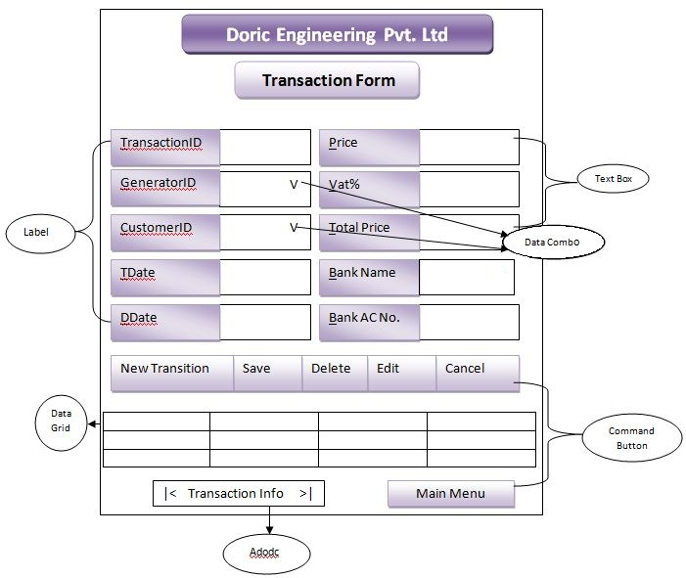

The input layout of the Customer Form and the Generator Form are similar to the input layout of the Transaction Form (Fig 2.10).

Output Layout of the Transaction Report (Fig 2.11)

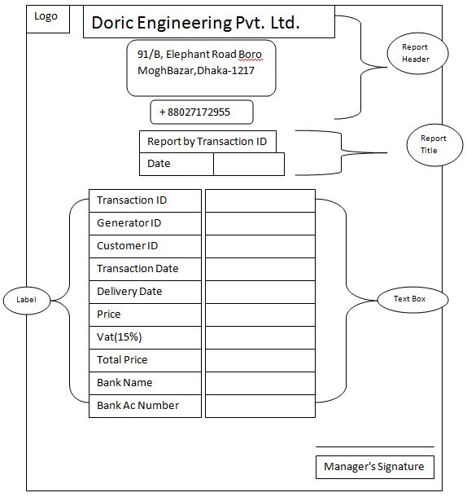

The design output layout of the Customer Report, Generator Report, etc is similar to that of the Transaction Report (Fig 2.11)

Database Design:

To illustrate the database of the new system, showing tables and how data is stored with data type, field size and data format with examples. It also shows the relationship among the tables.

The designed tables are in the following page.

Transaction Table

|  |  |  |  |  |
| --- | --- | --- | --- | --- |
| Field Name | Data Type | Field Size | Format | Example |
| TID (Primary Key) | Text | 6 | T##### | T10001 |
| GID | Text | 4 | G### | G101 |
| CID | Text | 5 | C#### | C1001 |
| TDate | Date | 10 | DD/MM/YYYY | 17/03/2007 |
| DDate | Date | 10 | DD/MM/YYYY | 17/04/2007 |
| Price | Currency | Long Integer | £……….. | £50,000.00 |
| Vat | Currency | Long Integer | £……….. | £7,500.00 |
| TotalPrice | Currency | Long Integer | £……….. | £57,500.00 |
| BankName | Text | 15 | N/A | EXIM |
| BankAcNumber | Number | Long Integer | N/A | 115877674 |

Customer Table

|  |  |  |  |  |
| --- | --- | --- | --- | --- |
| Field Name | Data Type | Field Size | Format | Example |
| CID (Primary Key) | Text | 5 | C#### | C1001 |
| CustomerName | Text | 25 | N/A | Afroz Al Mamun |
| Gender | Text | 6 | Male/Female | Male |
| PhoneNumber | Text | 11 | N/A | 01823357448 |
| EmailID | Text | 30 | ….@..... | afroz_27gmail.com |
| Designation | Text | 15 | N/A | Director |
| AssetName | Text | 20 | N/A | Icon College |
| PropertyType | Text | 10 | N/A | Company |
| Address | Text | 40 | N/A | D-Block Lalmatia, Dhaka |
| BankName | Text | 15 | N/A | EXIM |
| BankAcNum | Number | Long Integer | N/A | 115877674 |

Generator Table

|  |  |  |  |  |
| --- | --- | --- | --- | --- |
| Field Name | Data Type | Field Size | Format | Example |
| GID (Primary Key) | Text | 4 | G### | G101 |
| GType | Text | 10 | N/A | 24GFS |
| Model | Text | 10 | N/A | K4100D1 |
| ManufacturerCo | Text | 15 | N/A | Mindong |
| ManufacturingCountry | Text | 15 | N/A | Japan |
| Power_kW | Number | Long Integer | N/A | 24 |
| Voltage_V | Number | Long Integer | N/A | 230 |
| Current_A | Number | Long Integer | N/A | 1500 |
| VoltageModulationRate | Text | 10 | N/A | Exceed 95 |
| PotectionClass | Text | 10 | N/A | IP22 |
| Stock | Number | Long Integer | N/A | 15 |
| Price | Currency | Long Integer | £……….. | £45,000.00 |
| SalePrice | Currency | Long Integer | £……….. | £55,000.00 |

List of Variables

|  |  |
| --- | --- |
| Variable | Purpose/Position |
| xTID | Transaction Form, used in auto ID generation for the Transaction ID |
| xCID | Customer Form, used in auto ID generation for the Customer ID |
| xGID | Generator Form, used in auto ID generation for the Generator ID |
| d | Used to hold the string command for the delete function, in Transaction Form, Customer Form and Generator Form. |
| s | Used, in the Transaction Form, to hold the Numeric data of the “Stock” field in the Generator Table, subtract “1” from the stock and to update the “Stock” field. |
| g | Used to hold the string command for the Generator Type function, in Generator Form. |
| stockconf | Contains Boolean data, Used in Transaction Form for stock update. |

List of Formulas

|  |  |
| --- | --- |
| Field | Formula |
| Vat | txtVat = (Val(txtPrice) / 100) * 15 |
| Total Price | txtTPrice = Val(txtPrice) + Val(txtVat) |
| Delivery Date | txtDDate.Text = DateAdd("d", 15, txtTDate) |

The entity relationships in between the tables are as follows (Fig 2.12):

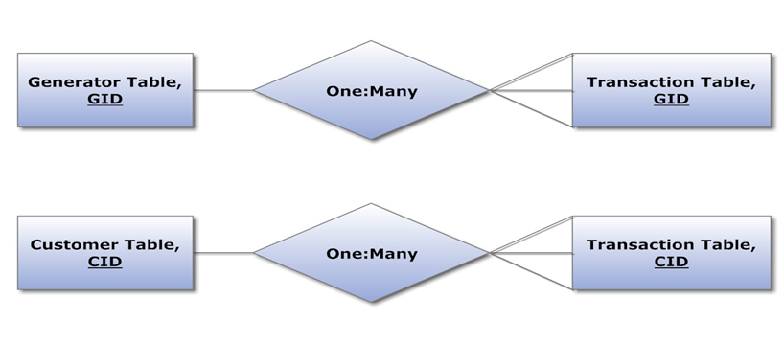

**9. Hardware requirement**

|  |  |  |
| --- | --- | --- |
| DEVICE | CONFIGURATION | Justification |
| Processor | Intel Core i3 (2.3 GHz) | For faster data processing |
| RAM | 2 GB | For storing more online application data temporarily |
| Hard disk | 500 GB | For storing more data on the database |
| DVD-ROM Drive | ASUS 52-X | For inputting data from optical disks |
| Input devices | Keyboard and Mouse | For manipulating/inputting transaction, customer, etc. details onto the database |
| Printer | Canon ip2772 inkjet | For printing transacting, generator, etc. reports |
| Monitor | 17” colour monitor | For viewing the running system |

**10. Software requirements**

There are many commercial software packages available to solve the drawbacks of the store. For example database software can be used to keep all the records of the store that will perform as the back-end and will also be used to store data. The front-end will be an interface created using a programming language. Both the database and the programming language will be used to establish the system, since they cannot be used alone and would easily carry out all the tasks required.

The options for the database software are:

• Microsoft Access

• Microsoft Excel

• Oracle

The options for the programming languages are:

• Visual Basic

• Quick Basic

Database Software:

|  |  |  |
| --- | --- | --- |
| Software | Advantages | Disadvantages |
| MS Access | 1. Easy to create a database.  2. Tables, forms, queries and report generating are easier by using wizard or design mode.  3. Easy to establish relationship between tables in a database. | 1. Can’t handle huge amount of data.  2. When access database file is used, it increases unnecessary size.  3. To solve a specific task, it needs  Visual Basic programming editor or script. |
| MS Excel | 1. Excellent program to create spreadsheet for various modelling and simulation.  2. It has numerous built in functions to solve the mathematical and logical problems.  3. It has different types of charts and graphs. | 1. User defined functions can’t be solved since all the functions are unalterable.  2. Does not support DBMS.  3. Does not create the attractive and user friendly interfaces to run the developed application program. |
| Oracle | 1. It handles huge amount of data.  2. Complex search and report generating can be done easily.  3. It has a strong and maximum data security facility to protect the data. | 1. It requires high skilled programming knowledge to develop the program.  2. It is expensive to afford.  3. It is difficult to program |

|  |  |  |
| --- | --- | --- |
| Software | Advantages | Disadvantages |
| Visual Basic | 1. It is very good application developer that comes with good number of useful tools and components.  2. It is easy and convenient to write program and debug, with it is instructions that is closer to English.  3. It has an attractive and a graphical user interface. | 1. Multiple projects cannot be opened or run in the same window.  2. The developer should have clear programming knowledge.  3. It needs high requirements as MS windows. |
| Quick Basic | 1. User defined functions can be solved.  2. Its syntax (instructions) is close to  English statement, so it is easy to understand.  3. It includes interpreter that converts a  written program into a compiled self | 1. It does not have the good and attractive interfaces.  2. Too many codes (instructions) have to be written to solve the problem. |

**Ideal software that can be used**

ORACLE 8i with Developer 2000 is very powerful to handle large amount of data which is very expedient. But it requires very high skilled and skilled programmer and also it is very expensive. Therefore I have chosen Microsoft Excel and Access.

**Best software to be used to solve the problem**

The database software that will be used would be Microsoft Access 2000 or higher. This will be used as data holder and the programming language would be Microsoft Visual Basic 6.0 (VB98) that will perform as the manipulator of data. It is wise to use both of these; since Access supports all the modules and Structured Query Language (SQL) required for developing the system and also it is less costly. Visual Basic will be used to create the interfaces, since it supports SQL for input and output of data to and from the database, as it will be connected to the database via Microsoft Jet Engine 4.0 using ActiveX Data Object (ADO) control.

**Justifications for writing a problem**

The tasks like validation checking, searching records and report generating would become handy only by a written program though programming language is a bit difficult to learn and utilize. So I used Visual Basic which is comparatively easier to write the program which has facilities that I would need to produce the software, as follows:

* 1. Its Graphical User Interface has a professional look but yet it is user-friendly
  2. When the user writes an object’s name while programming, the programming editor provides the properties and methods automatically
  3. Writing the program is done conveniently as the required tools and components are provided.
  4. Visual Basic programming language allows modular programming, which increases the usability of programs as a common function.
  5. Different types of colour codes are used to show the different modes of the program, that helps the programmer to know whether he is going in right way or not.

Moreover, any kind of calculation and checking can be performed. Additionally, the program would give proper security to the records by the use of passwords.

**11. Method of solution**

I used Microsoft Office Access 2007 to create the database which contained the transaction table, customer table, product table, etc.

* Click on Start. Open All Programs. Click on Microsoft Office Access2007. Create blank table.

I used Microsoft Visual basic 6.0 to create the data manipulation interface.

* Click on Start. Open All Programs. Open on Microsoft Visual Basic 6.0. Click on Microsoft Visual Basic 6.0. Open **Standard EXE**.

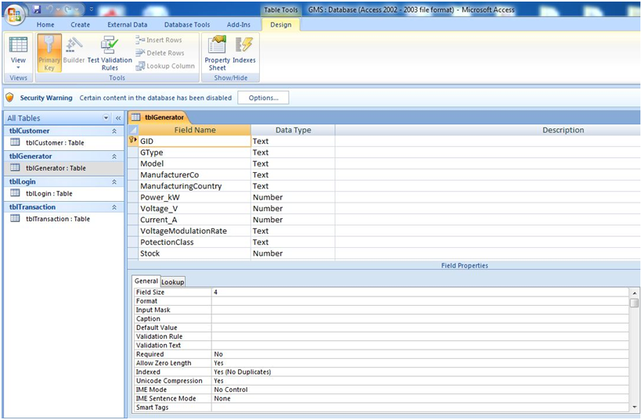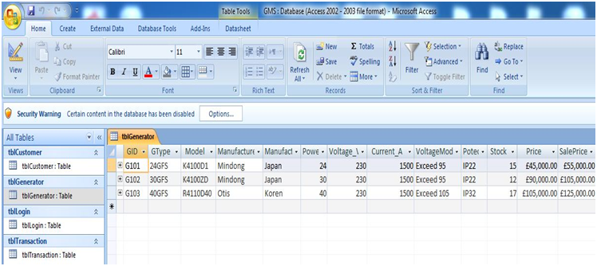

Data Type

Primary Key (No Duplication)

Generator Table Datasheet view (Fig 3.02)

Generator Table Design View (Fig 3.1**)**

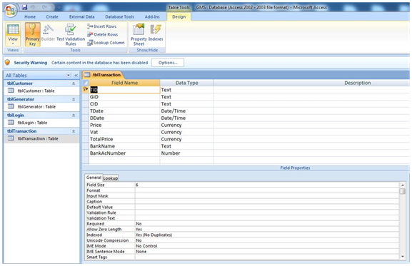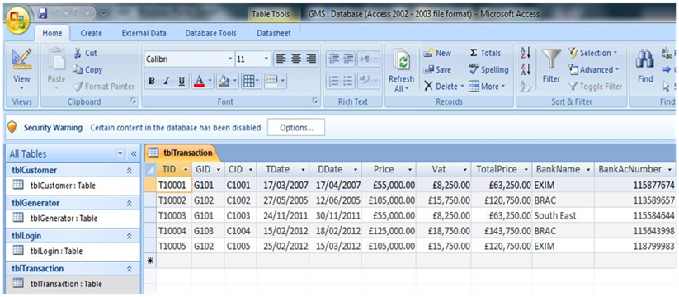

Transaction Table Datasheet View (Fig 3.4)

Data Type

Transaction Table Design View (Fig 3.3)

Primary Key (No Duplication)

Relationship Diagram (Fig 3.05)

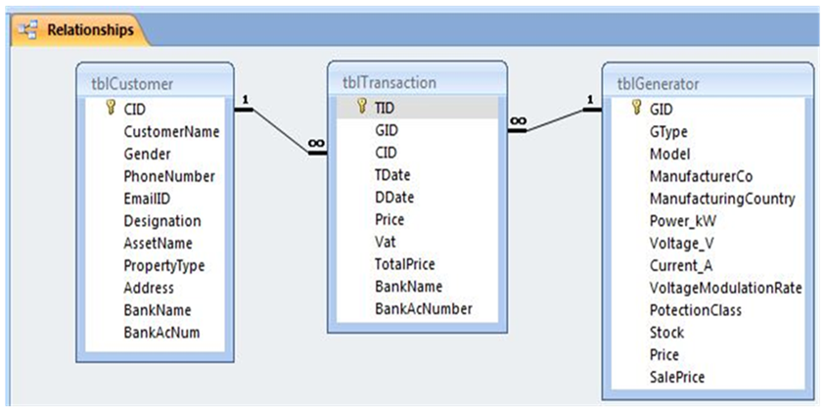

The relationship diagram (Fig 3.05) shows how the **primary** **keys** of the transaction table is related to the **foreign** **keys** of the generator table and customer table with **one is to many** relationships.

Tool Box (Fig 3.06)

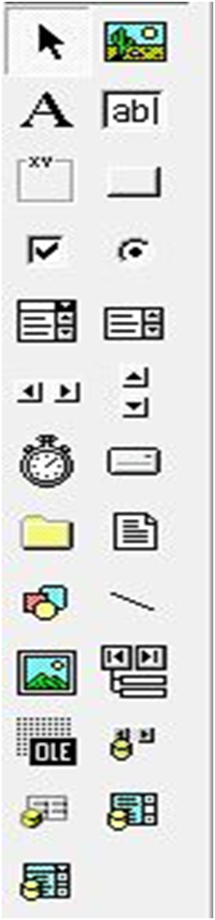

Option Button

Pointer

Text Box

Command Button

Combo Box

Adodc

Data Grid

Data Combo

Label

Frame

Input layout of Transaction Form (Fig 3.07)

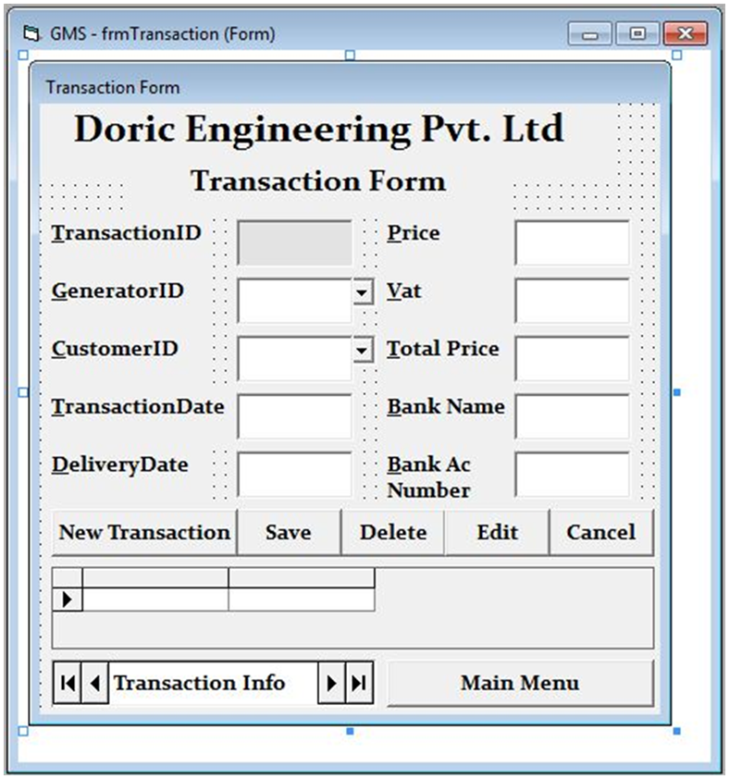

Text Box

Label

Command Button

Data Grid

Adodc

The Input layout of the **Customer Form** and the **Generator Form** is similar to the input layout of the **Transaction Form (Fig 3.7).** The **Login Form** and the **Main Form** use similar tools as the transaction from.

Search and Report Form (Fig 3.08)

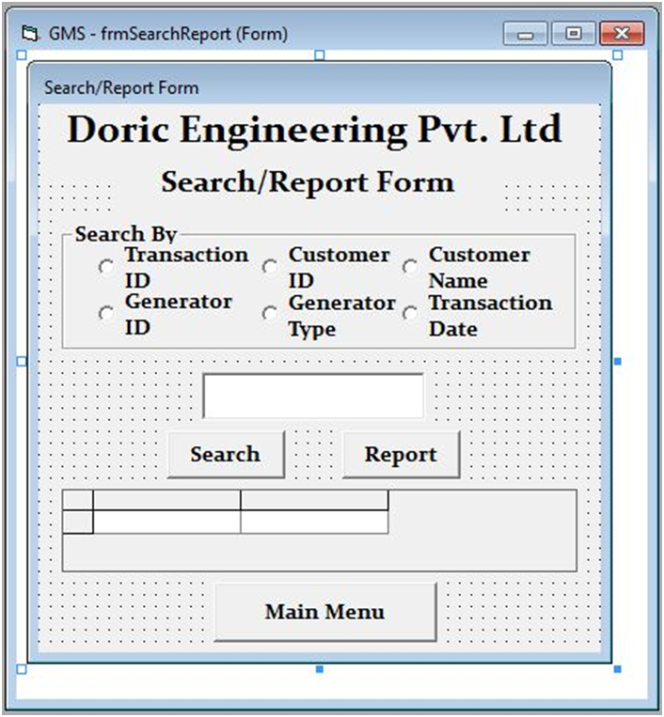

Input Box for data query

Do query by:

Frame

I used the **Search and Report Form (Fig 3.8)** to input data to refer to for searching and report. I used **Data Environment (Fig 3.9)** and the **SQL Statement (Fig 3.10)** according to the query requirement to connect to the table in the database to enable query for data. And also, the report option is available to display the query as a **report (Fig 3.11)**.

Data Environment (Fig 3.09)

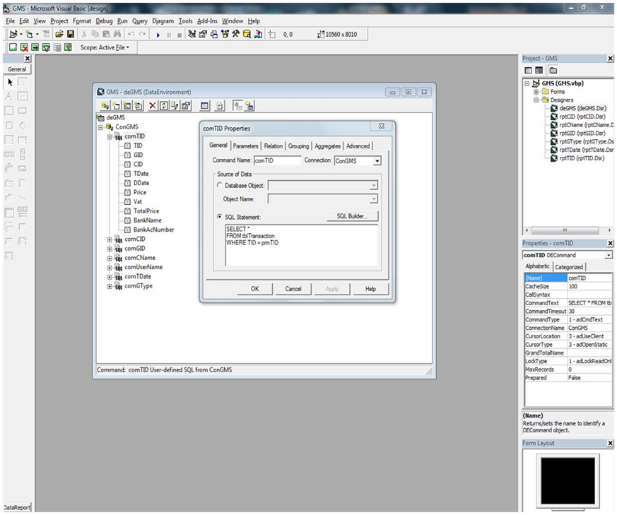

SELECT *

FROM tblTransaction

WHERE TID = prmTID

“prm TID” is the parameter for the Transaction ID based query and report.

SQL Statement Table (Fig 3.10)

|  |  |
| --- | --- |
| Command Name | SQL Statement |
| comTID | SELECT * FROM tblTransaction WHERE TID = prmTID |
| comCID | Select * From tblCustomer WHERE CID=prmCID |
| comGID | SELECT * FROM tblGenerator WHERE GID=prmGID |
| comCName | SELECT * FROM tblCustomer WHERE CustomerName=prmCustomerName |
| comUserName | SELECT * FROM tblLogin WHERE UserName=prmUserName |
| comTDate | SELECT * FROM tblTransaction Where TDate=prmTDate |
| comGType | SELECT * FROM tblGenerator WHERE GType=prmGType |

Report by Transaction ID (Fig 3.11)

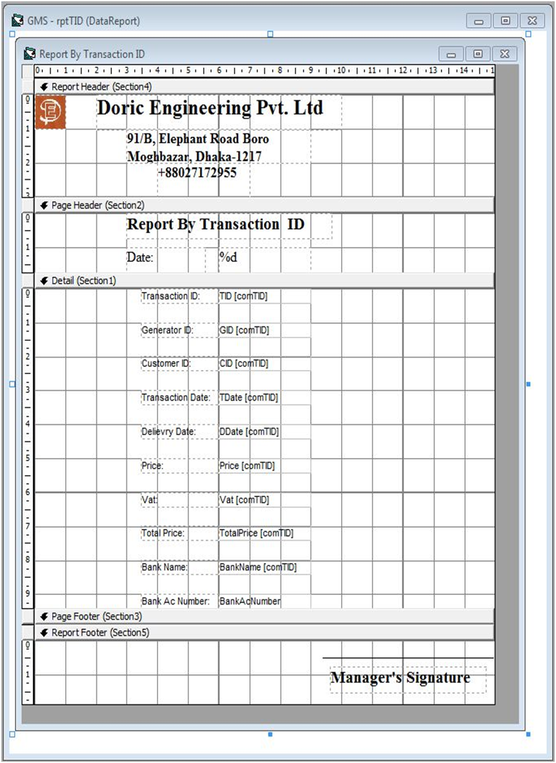

Data Label

Logo

Data Fields showing data extracted from the database table

The Report by **Customer ID**, **Generator ID**, etc are similar to that of the **Transaction ID (Fig 3.11).**

**12. Accurate method of solution**

According to the computer related objectives mentioned in the analysis phase and the action plan in the design phase whether those are achieved.

*Co.1 User interface: The interface of the computerized system should be user friendly so that it is easier to use, by using navigation tools, drop-down lists, etc.*

* Has been successfully achieved by creating forms and using the tools available in the software Visual Basic 6.0. (Pg 64 - 65; Fig 4.36-4.38)

*Co.2 Data storage: Huge Data should be stored in an orderly manner in separate tables for transaction, customer, etc.*

* Has been successfully achieved by creating tables in a database and storing data in them accordingly. (Pg 24 - 25; Fig 3.02, 3.04)

*Co.3 Avoid data duplication and redundancy: Data will not be duplicated and data redundancy must be avoided by the use of product key, relationship between primary key & foreign key, as a result consistency of data will be increased, like Customer ID used in Transaction table.*

* Has been successfully achieved by creating relationships between tables using primary keys. (Pg 24 - 25, 26; Fig 3.01, 3.03, 3.05)

*Co.4 Auto ID Generation: To make the records in the table unique, like Transaction ID, Customer ID.*

- Has been successfully achieved by using the auto ID generating codes. (60 - 61; Fig 4.38 - 4.40)

*Co.5 Validation: There should be validation and verification checks to reduce the errors in data.*

* Has been successfully achieved by doing validation checks (Pg 39 - 42, 51-54; Fig 3.18 - 3.21, 4.01 - 4.22) by the validation codes in the coding page (Pg 39 - 42, 44 - 46).

*Co.6 Search & Reports: The new system should provide faster data searching and faster data reports with much less human intervention.*

* Has been successfully achieved by creating a **Search and Report Form** (Pg 29; Fig 3.8), **Data Environment** (Pg 30; Fig 3.09) and the **SQL Statements** (Pg 30; Fig 3.10)using Visual Basic 6.0.

*Co.7 Security: There should be a security system to prevent unauthorized people from viewing confidential data.*

* Has been successfully achieved by using the **Login Form (**Pg 66 - 67; Fig 4.41 - 4.46)security codes in coding page.

**13. Programming Code**

Data Manipulation

Adding a new record (Fig 3.12)

|  |  |
| --- | --- |
| addnew.JPG | |
| Code | Purpose |
| adcTransaction.Recordset.MoveLast  xTID = Right(txtTID, 5)  adcTransaction.Recordset.AddNew  txtTID = "T" + CStr(xTID + 1) | For adding a new record. Then performing auto ID generation - first by taking the last records numeric code as “xTID” and then adding “1” to it and then adding it as a text next to “T”. |
| txtTDate.Text = Date | To set the current date as the “Transaction Date”. |
| txtDDate.Text = DateAdd("d", 15, Date) | To add 15 days to the Transaction Date, which will be the Delivery Date of the product. |
| MsgBox "Record Added Successfully", vbInformation, "New Transaction" | To give a message to the user that the record was added without any problems or errors. |

Editing a record (Fig 3.13)

|  |  |
| --- | --- |
| edit.JPG | |
| Code | Purpose |
| txtTID.Locked = False  txtGID.Locked = False  dcmbGID.Locked = False  txtCID.Locked = False  dcmbCID.Locked = False  txtTDate.Locked = False  txtDDate.Locked = False  txtPrice.Locked = False  txtVat.Locked = False  txtTPrice.Locked = False  txtBName.Locked = False  txtBAcNum.Locked = False | To allow all the fields to be edited, by unlocking them the field lock. |
| MsgBox "Data Edit Has Successfully Been Enabled", vbInformation, "Edit....." | To give a message to the user that the record can now be edited. |

Deleting a record (Fig 3.14)

|  |  |
| --- | --- |
| delete 1.JPG | delete 2.JPG |
| Code | Purpose |
| d = MsgBox("Are you sure that you want to delete?", vbYesNo, "Delete.....") | “d” is used as a variable to store the decision taken when the delete query was made.  A decision box is shown to ask the user to confirm his “delete action”. |
| If d = vbYes Then  adcTransaction.Recordset.Delete  adcTransaction.Refresh  Else:  Exit Sub  End If | To delete the selected record if the decision was “Yes”, else exit from the running from function. |
| MsgBox "Record Deleted Successfully", vbInformation, "Deleted....." | To give a message to the user that the record has been deleted. |

Saving a record (Fig 3.15)

|  |  |
| --- | --- |
| save.JPG | |
| Code | Purpose |
| adcTransaction.Recordset.Update | To update the all the fields/ amended fields in the Transaction Table. |
| s=adcGenerator.Recordset.Fields("Stock").Value  s = s - 1  With adcGenerator.Recordset  .Fields("Stock") = s  .Update  End With | To subtract “1” from the stock of the selected generator.  To update the “Stock” field in the Generator Table. |
| MsgBox "Record Saved Successfully", vbInformation, "Saved....." | To give a message to the user that the record has been saved. |

Data Searching and Report

Searching for a record (Fig 3.16)

|  |  |
| --- | --- |
| search.JPG | |
| Code | Purpose |
| If optTID.Value = True Then  txtSearchReport.SetFocus | To do the following query functions if it is selected and focus the cursor in the SearchReport text box. |
| If deGMS.rscomTID.State = adStateOpen Then  deGMS.rscomTID.Close  End If | To close the data environment (deGMS) object if it is open, to avoid unexpected errors. |
| deGMS.comTID Trim(txtSearchReport.Text) | To search using the SQL code in the selected command in the data environment (deGMS ) using the query request in the SearchReport text box. |
| grdSearch.DataMember = "comTID" | To display the search result in the Search Grid (grdSearch). |
| MsgBox "Search Result Shown", vbInformation, "Search" | To give a message to the user that the query for the record has been successful. |

Data Report (Fig 3.17)

|  |  |
| --- | --- |
| Transaction Report run.JPG | |
| Code | Purpose |
| If optTID.Value = True Then  txtSearchReport.SetFocus | To do the following report function and focus the cursor in the SearchReport text box. |
| If deGMS.rscomTID.State = adStateOpen Then  deGMS.rscomTID.Close  End If | To close the data environment object if it is open, to avoid unexpected errors. |
| deGMS.comTID Trim(txtSearchReport.Text) | To make a report using the SQL code in the selected command in the data environment (deGMS ) using the query request in the SearchReport text box. |
| rptTID.Show | Show the Transaction Report, such as the above. |

Validation

Length Check (Fig 3.18)

|  |  |
| --- | --- |
| length check.JPG | |
| Code | Purpose |
| If Len(txtCName.Text) > 25 Then  MsgBox "Customer Name cannot be more than 25 characters", vbCritical, "Error"  End If | Used in the Customer Name field in the Transaction Form to check the name input if the length is more than 25 characters and shows error message in case the data is more than 25 characters. |

Format Check (Fig 3.19)

|  |  |
| --- | --- |
| format check.JPG | |
| Code | Purpose |
| If KeyAscii = 13 Then  If txtTID Like "T#####" Then  Else  MsgBox "Wrong Format T#####", vbCritical, "Error Input"  End If  End If | Used to check if the Transaction ID is in the correct format or not and shows error message in case the data is in the wrong format. |

Type Check (Fig 3.20)

|  |  |
| --- | --- |
| type check.JPG | |
| Code | Purpose |
| If IsNumeric(txtPhNum.Text) = True Then  Else: MsgBox "Phone Number can be numeric only", vbCritical, "Error"  txtPhNum.Text = ""  txtPhNum.SetFocus  End If | Used in Phone Number text box in the Customer Form to check if data is only numeric and shows error message if data of any other type is present. |

Presence Check (Fig 3.21)

|  |  |
| --- | --- |
| presense chk2.JPG | presense chk.JPG |
| Code | Purpose |
| If KeyAscii = 13 And txtGID = "" Then  MsgBox "Empty Field", vbCritical  txtGID.SetFocus  ElseIf KeyAscii = 13 Then  txtCID.SetFocus  End If | Used to check the field "Generator ID" in the Transaction Table to find if the field contains null value and prevents from moving the cursor to the Customer ID field if data is not present and also shows error message in case the data is not present. |

To see other workings of Data Manipulation, Search and Report, Validation, Security including other Forms see Testing Phase (Page 49-65).

Other Codes

**Data manipulation**

**Customer Form**

*Code for adding a new record*

adcCustomer.Recordset.MoveLast

xCID = Right(txtCID, 4)

adcCustomer.Recordset.AddNew

txtCID = "C" + CStr(xCID + 1)

*Code for editing a record*

txtCName.Locked = False

txtGender.Locked = False

cmbGender.Locked = False

txtPhNum.Locked = False

txtPType.Locked = False

txtAName.Locked = False

txtAddress.Locked = False

txtDesignation.Locked = False

txtBName.Locked = False

txtBAcNum.Locked = False

*Code for deleting a record*

d = MsgBox("Are you sure that you want to delete?", vbYesNo, "Delete.....")

If d = vbYes Then

adcCustomer.Recordset.Delete

MsgBox "Record Deleted Successfully", vbInformation, "Deleted....."

adcCustomer.Refresh

adcCustomer.Recordset.Sort = "CID"

Else:

Exit Sub

End If

*Code for saving a record*

adcCustomer.Recordset.Update

**Generator Form**

*Code for adding a new record*

adcGenerator.Recordset.MoveLast

xGID = Right(txtGID, 3)

adcGenerator.Recordset.AddNew

txtGID = "G" + CStr(xGID + 1)

*Code for editing a record*

txtGID.Locked = False

txtGType.Locked = False

txtModel.Locked = False

txtMan.Locked = False

txtManCountry.Locked = False

txtPower.Locked = False

txtVoltage.Locked = False

txtCurrent.Locked = False

txtVMR.Locked = False

txtPCase.Locked = False

txtStock.Locked = False

txtPrice.Locked = False

txtSPrice.Locked = False

*Code for deleting a record*

d = MsgBox("Are you sure that you want to delete?", vbYesNo, "Delete.....")

If d = vbYes Then

adcGenerator.Recordset.Delete

MsgBox "Record Deleted Successfully", vbInformation, "Deleted....."

adcGenerator.Refresh

Else: Exit Sub

End If

*Code for saving a record*

adcGenerator.Recordset.Update

**Validation**

**Transaction Form**

*Format check for Transaction Date*

Private Sub txtTDate_KeyPress(KeyAscii As Integer)

If KeyAscii = 13 Then

If txtTID Like "DD/MM/YYYY" Then

txtGID.SetFocus

Else

MsgBox "Correct Format: DD/MM/YYYY", vbCritical, "Error Input"

End If

End If

End Sub

**Customer Form**

*Format check for Customer ID*

Private Sub txtCID_KeyPress(KeyAscii As Integer)

If KeyAscii = 13 Then

If txtCID Like "C####" Then

txtCName.SetFocus

Else

MsgBox "Correct Format: C####", vbCritical, "Error Input"

End If

End If

End Sub

*Length check for Customer Name*

Private Sub txtCName_Change()

If Len(txtCName.Text) > 25 Then

MsgBox "Customer Name cannot be more than 25 characters", vbCritical, "Error"

End If

End Sub

*Format check for Email*

Private Sub txtEmail_Validate(Cancel As Boolean)

If InStr(1, txtEmail, "@") = 0 Then

MsgBox "Email Address Not Valid", vbCritical, "Error Input"

txtEmail.SetFocus

Exit Sub

End If

End Sub

*Presence check for Bank Name*

Private Sub txtBName_KeyPress(KeyAscii As Integer)

If KeyAscii = 13 And txtBName = "" Then

MsgBox "Empty Field", vbCritical

txtBName.SetFocus

ElseIf KeyAscii = 13 Then

txtBAcNum.SetFocus

End If

End Sub

*Type check for Bank Account Number*

Private Sub txtBAcNum_KeyPress(KeyAscii As Integer)

If IsNumeric(txtBAcNum.Text) = True Then

Else: MsgBox "Bank Account Number can be numeric only", vbCritical, "Error"

txtBAcNum.Text = ""

txtBAcNum.SetFocus

End If

End Sub

**Generator Form**

*Format check for Generator ID*

Private Sub txtGID_KeyPress(KeyAscii As Integer)

If KeyAscii = 13 Then

If txtGID Like "G###" Then

Else

MsgBox "Correct Format: G###", vbCritical, "Error Input"

End If

End If

End Sub

*Presence check for Model*

Private Sub txtModel_KeyPress(KeyAscii As Integer)

If KeyAscii = 13 And txtModel = "" Then

MsgBox "Empty Field", vbCritical

txtModel.SetFocus

ElseIf KeyAscii = 13 Then

txtMan.SetFocus

End If

End Sub

*Range check for Stock*

Private Sub txtStock_KeyPress(KeyAscii As Integer)

If KeyAscii = 13 Then

If Val(txtStock.Text) > 0 And Val(txtStock.Text) <= 50 Then

Else: MsgBox "Stock is out of range", vbCritical, "Error"

txtStock.Text = ""

txtStock.SetFocus

Exit Sub

End If

If KeyAscii = 13 Then

txtPrice.SetFocus

End If

End If

End Sub

**Formula**

**Transaction Form**

*Code for calculating Vat*

Private Sub txtPrice_Change()

txtVat = (Val(txtPrice) / 100) * 15

End Sub

*Code for calculating Total Price*

Private Sub txtPrice_Change()

txtTPrice = Val(txtPrice) + Val(txtVat)

End Sub

**Login Form Codes**

*Code to check for correct User Name and Password*

Private Sub cmdLogin_Click()

If deGMS.rscomUserName.State = adStateOpen Then

deGMS.rscomUserName.Close

End If

deGMS.comUserName Trim(txtUserName.Text)

If deGMS.rscomUserName.RecordCount = 0 Then

MsgBox "Invalied User Name", vbCritical

Exit Sub

End If

If txtPassword.Text = deGMS.rscomUserName.Fields("Password").Value Then

MsgBox "Welcome", vbInformation

Unload Me

frmMain.Show

Else: MsgBox "Invalid Password", vbCritical

txtPassword.SetFocus

End If

End Sub

Code for Closing the software

Private Sub cmdClose_Click()

End

End Sub

**Main Form Codes**

*Code for Closing the software*

Private Sub cmdClose_Click()

End

End Sub

*Code for opening Customer From*

Private Sub cmdfrmCustomer_Click()

Unload Me

frmCustomer.Show

End Sub

*Code for opening Generator From*

Private Sub cmdfrmGenerator_Click()

Unload Me

frmGenerator.Show

End Sub

*Code for Loging Out*

Private Sub cmdfrmLogin_Click()

Unload Me

frmLogin.Show

End Sub

*Code for opening Search/Report From*

Private Sub cmdfrmSearchReport_Click()

Unload Me

frmSearchReport.Show

End Sub

*Code for opening Transaction From*

Private Sub cmdfrmTransaction_Click()

Unload Me

frmTransaction.Show

End Sub

**Search/Report Form**

*Code for searching data*

Private Sub cmdSearch_Click()

If optTID.Value = True Then

txtSearchReport.SetFocus

If deGMS.rscomTID.State = adStateOpen Then

deGMS.rscomTID.Close

End If

deGMS.comTID Trim(txtSearchReport.Text)

grdSearch.DataMember = "comTID"

MsgBox "Search Result Shown", vbInformation, "Search"

ElseIf optGID.Value = True Then

If deGMS.rscomGID.State = adStateOpen Then

deGMS.rscomGID.Close

End If

deGMS.comGID Trim(txtSearchReport.Text)

grdSearch.DataMember = "comGID"

MsgBox "Search Result Shown", vbInformation, "Search"

ElseIf optGType.Value = True Then

If deGMS.rscomGType.State = adStateOpen Then

deGMS.rscomGType.Close

End If

deGMS.comGType Trim(txtSearchReport.Text)

grdSearch.DataMember = "comGType"

MsgBox "Search Result Shown", vbInformation, "Search"

ElseIf optCID.Value = True Then

If deGMS.rscomCID.State = adStateOpen Then

deGMS.rscomCID.Close

End If

deGMS.comCID Trim(txtSearchReport.Text)

grdSearch.DataMember = "comCID"

MsgBox "Search Result Shown", vbInformation, "Search"

ElseIf optCName.Value = True Then

If deGMS.rscomCName.State = adStateOpen Then

deGMS.rscomCName.Close

End If

deGMS.comCName Trim(txtSearchReport.Text)

grdSearch.DataMember = "comCName"

MsgBox "Search Result Shown", vbInformation, "Search"

ElseIf optTDate.Value = True Then

txtSearchReport.SetFocus

If deGMS.rscomTDate.State = adStateOpen Then

deGMS.rscomTDate.Close

End If

deGMS.comTDate Trim(txtSearchReport.Text)

grdSearch.DataMember = "comTDate"

MsgBox "Search Result Shown", vbInformation, "Search"

End If

End Sub

*Code for generating report*

Private Sub cmdReport_Click()

If optTID.Value = True Then

txtSearchReport.SetFocus

If deGMS.rscomTID.State = adStateOpen Then

deGMS.rscomTID.Close

End If

deGMS.comTID Trim(txtSearchReport.Text)

rptTID.Show

ElseIf optGID.Value = True Then

txtSearchReport.SetFocus

If deGMS.rscomGID.State = adStateOpen Then

deGMS.rscomGID.Close

End If

deGMS.comGID Trim(txtSearchReport.Text)

rptGID.Show

ElseIf optCID.Value = True Then

txtSearchReport.SetFocus

If deGMS.rscomCID.State = adStateOpen Then

deGMS.rscomCID.Close

End If

deGMS.comCID Trim(txtSearchReport.Text)

rptCID.Show

ElseIf optCName.Value = True Then

txtSearchReport.SetFocus

If deGMS.rscomCName.State = adStateOpen Then

deGMS.rscomCName.Close

End If

deGMS.comCName Trim(txtSearchReport.Text)

rptCName.Show

ElseIf optGType.Value = True Then

txtSearchReport.SetFocus

If deGMS.rscomGType.State = adStateOpen Then

deGMS.rscomGType.Close

End If

deGMS.comGType Trim(txtSearchReport.Text)

rptGType.Show

ElseIf optTDate.Value = True Then

txtSearchReport.SetFocus

If deGMS.rscomTDate.State = adStateOpen Then

deGMS.rscomTDate.Close

End If

deGMS.comTDate Trim(txtSearchReport.Text)

rptTDate.Show

End If

End Sub

**14. Test strategy**

To fulfil my objective of the software to run smoothly, I used different validation techniques to test for three types of test data (Normal, Abnormal and Extreme). The following are the testing that I formed upon several fields:

* **Length** **Check** - This checks if the length of the data entered is within the limit.
* **Format** **Check** - This checks if the data entered is in the correct format.
* **Type** **Check** - This check if the data entered is the correct data type.
* **Presence** **Check** - This checks if the data is present in the text box.
* **Range Check** - This checks if the value of the data is within a certain range.

I planned a validation test strategy for some of my fields for checking for different data sets.

Then I showed the workings of different forms for data manipulation and search. I also included the security system and showed how it works.

Validation Test planning (Co.5)

Transaction Form

|  |  |  |  |  |
| --- | --- | --- | --- | --- |
| Field Name | Test Data | Data Type | Validation | Expectation |
| TID | T10005 | Normal | Format Check | Accepted |
| T100057 | Abnormal | Error Message |
| Transaction Date | 23/03/2013 | Normal | Format Check | Accepted |
| 23/03/13 | Abnormal | Error Message |

Customer Form

|  |  |  |  |  |
| --- | --- | --- | --- | --- |
| Field Name | Test Data | Data Type | Validation | Expectation |
| CID | C1006 | Normal | Format Check | Accepted |
| C10068 | Abnormal | Error Message |
| CustomerName | Zeba Farzana | Normal | Length Check | Accepted |
| Fayez Ahmed Jahangir Masud | Abnormal | Error Message |
| EmailID | akbar.ovi@yahoo.com | Normal | Format Check | Accepted |
| akbarovi71 | Abnormal | Error Message |
| BankName | Exim | Normal | Presence Check | Accepted |
| " " | Abnormal | Error Message |
| BankAcNum | 118799983 | Normal | Type Check | Accepted |
| 11879a | Abnormal | Error Message |

Generator Form

|  |  |  |  |  |
| --- | --- | --- | --- | --- |
| Field Name | Test Data | Data Type | Validation | Expectation |
| GID | G104 | Normal | Format Check | Accepted |
| G1045 | Abnormal | Error Message |
| Model | K5100ZA | Normal | Presence Check | Accepted |
| " " | Abnormal | Error Message |
| Stock | 17 | Normal | Range Check | Accepted |
| -1 | Abnormal | Error Message |
| 1, 50 | Extreme | Accepted |

Validation Test screenshots

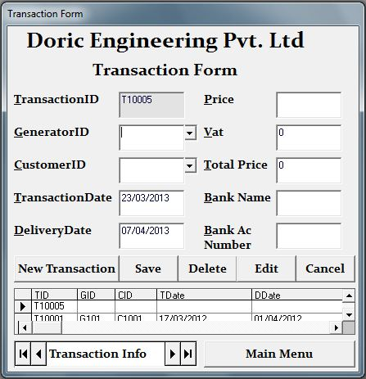

Fig 4.01

Fig 4.02

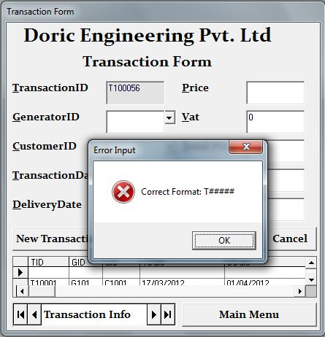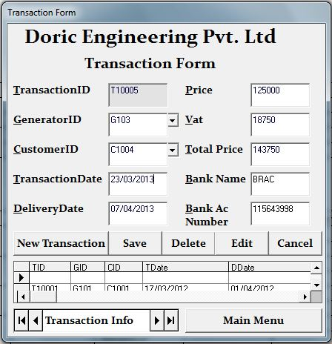

Fig 4.03

Fig 4.04

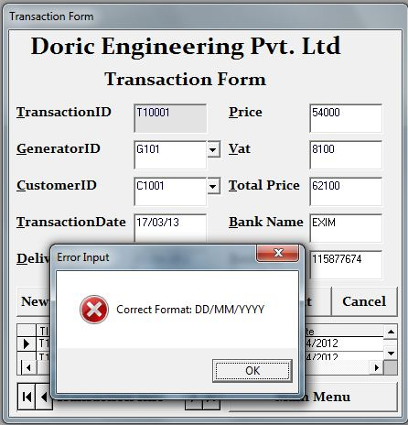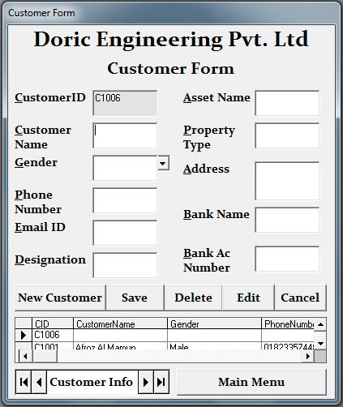

Fig 4.05

Fig 4.06

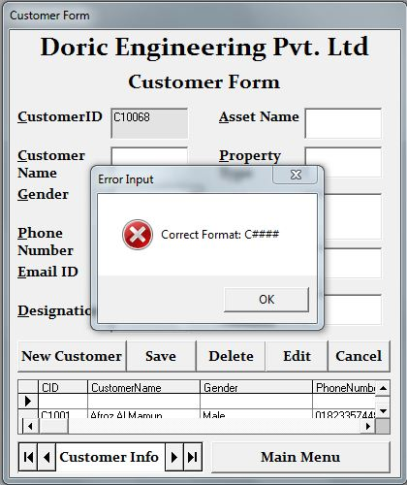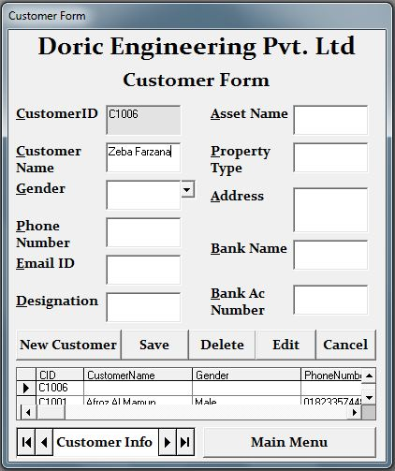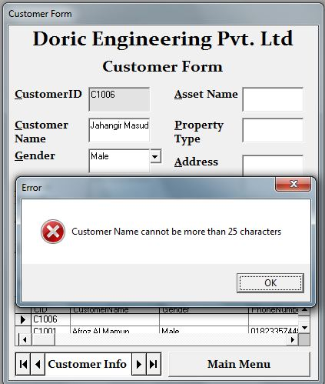

Fig 4.07

Fig 4.08

Fig 4.09

Fig 4.10

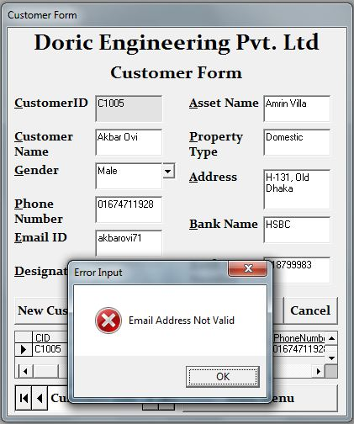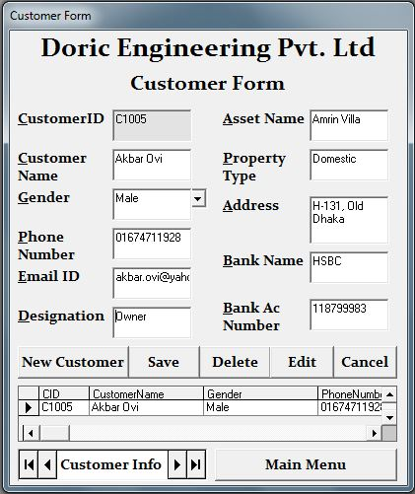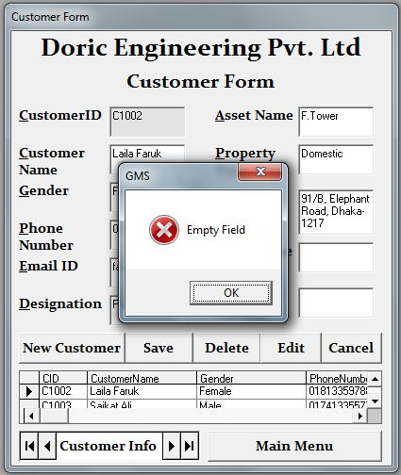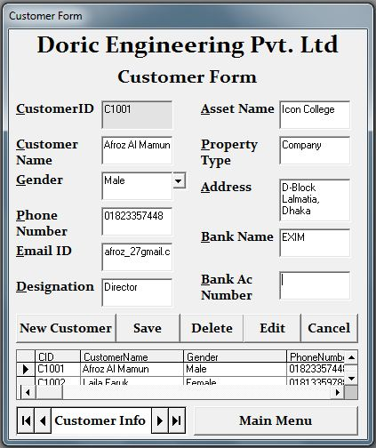

Fig 4.11

Fig 4.12

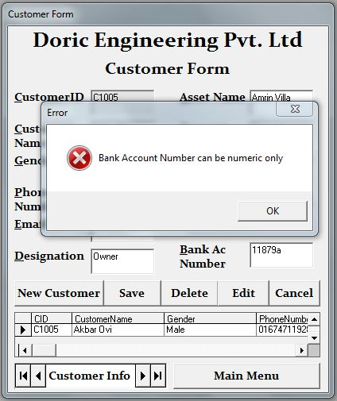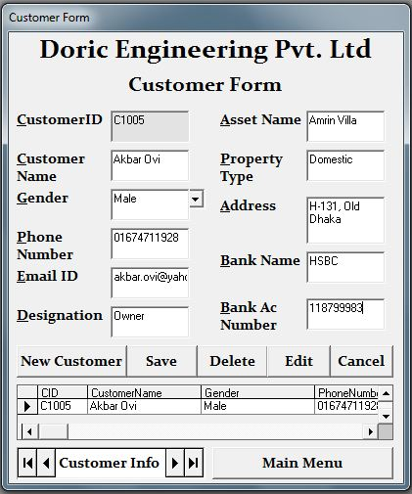

Fig 4.13

Fig 4.14

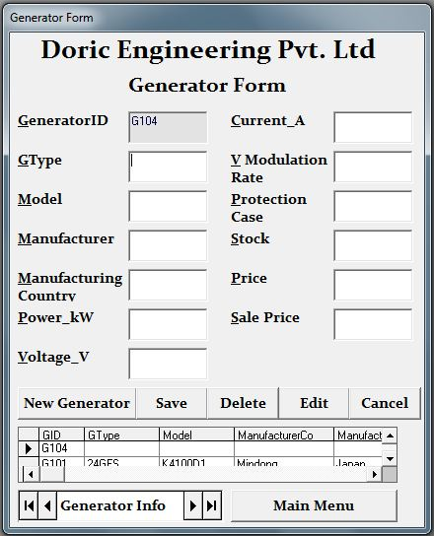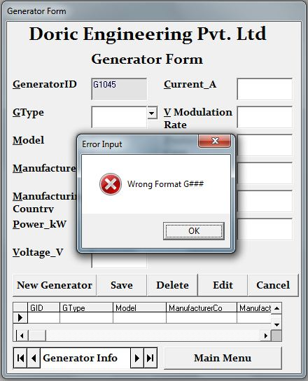

Fig 4.15

Fig 4.16

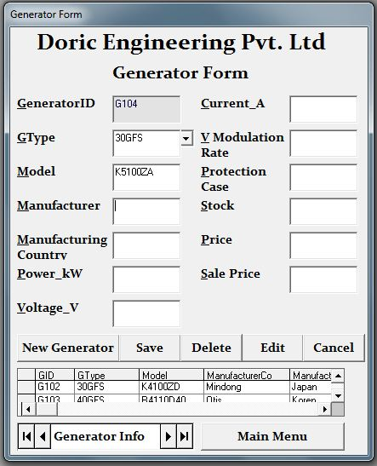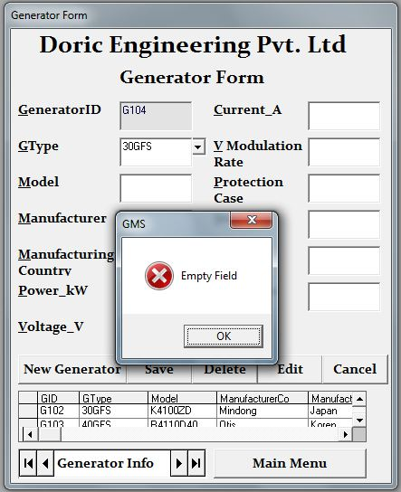

Fig 4.17

Fig 4.18

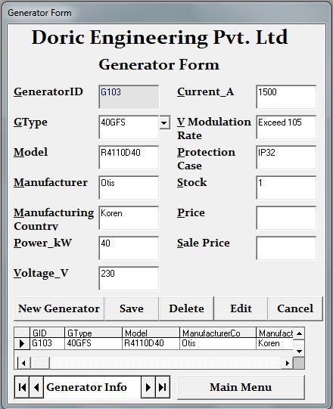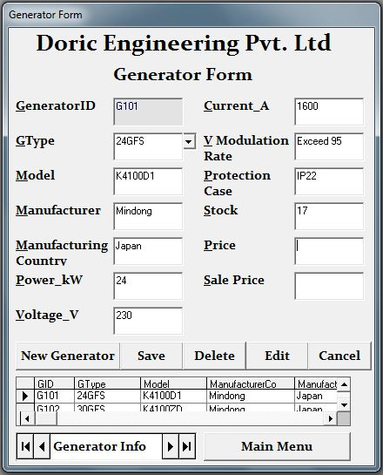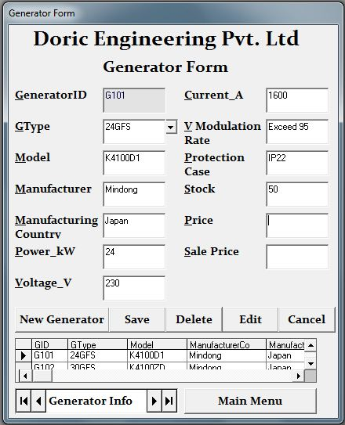

Fig 4.19

Fig 4.20

Fig 4.21

Fig 4.22

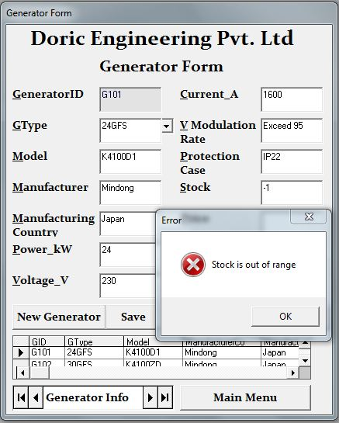

Data Manipulation Screenshots (Customer Form & Generator Form)

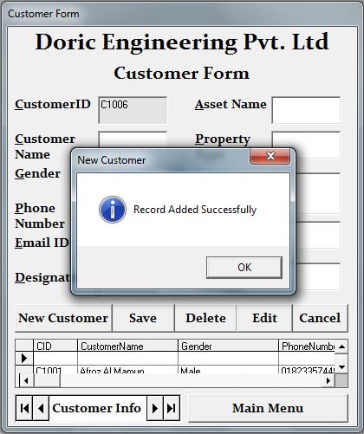

Auto generated ID

New blank record added

Fig 4.23

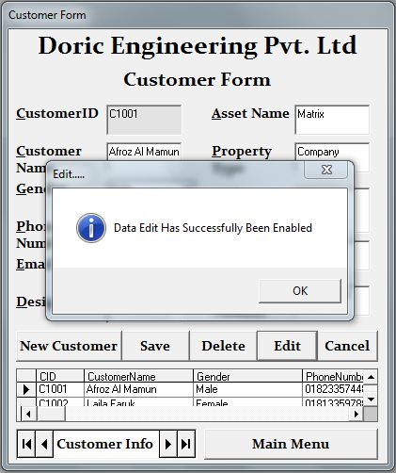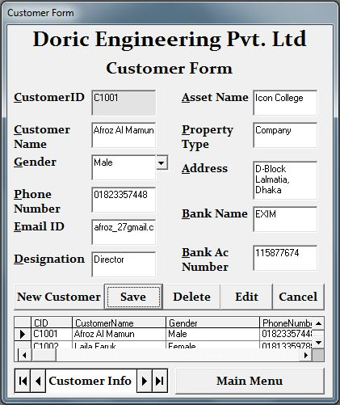

Edited Field

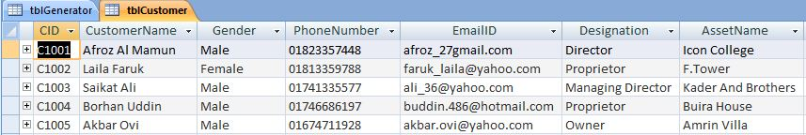

Field Edited in Database

Fig 4.24

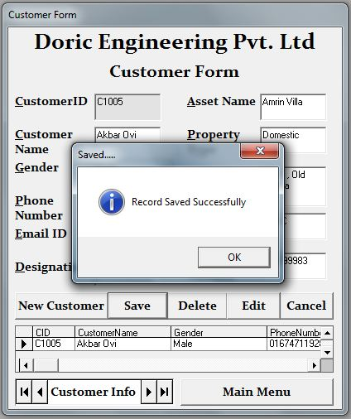

Record Saved into Database

Fig 4.25

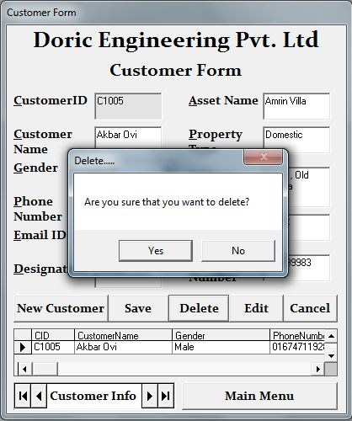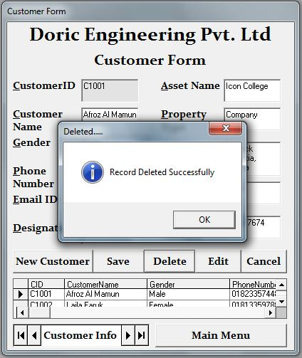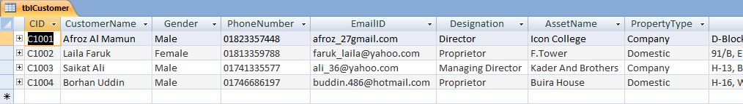

Record Deleted from Database

Fig 4.26

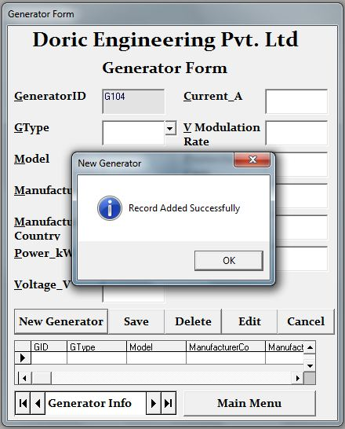

Auto generated ID

New blank record added

Fig 4.27

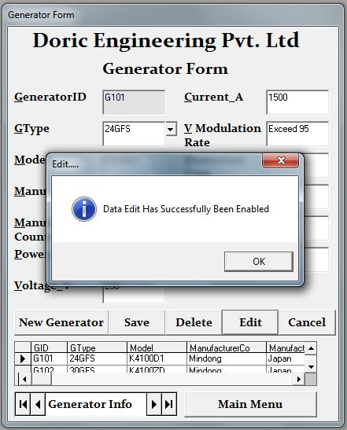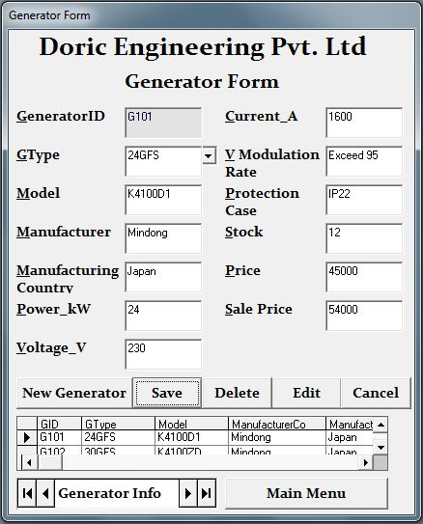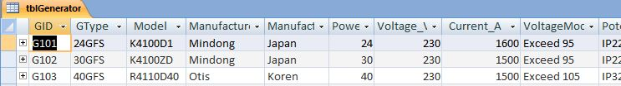

Edited Field

Field Edited in Database

Fig 4.28

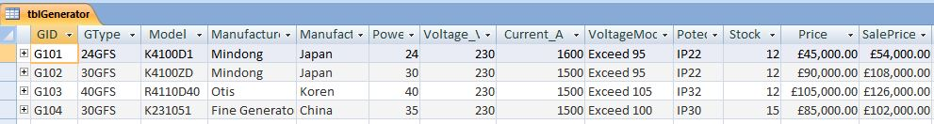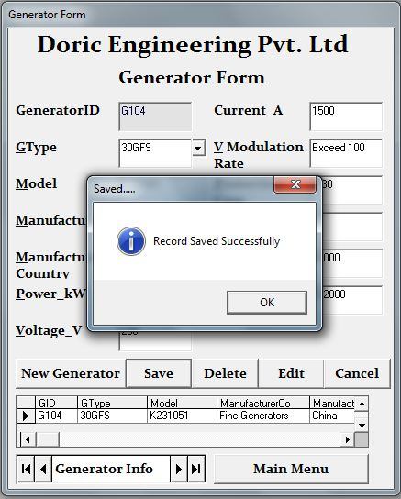

Record Saved into Database

Fig 4.29

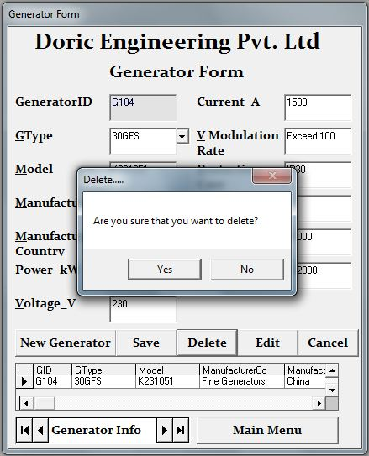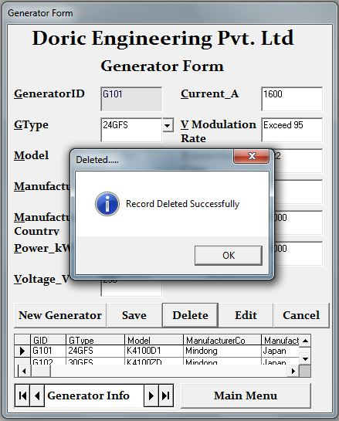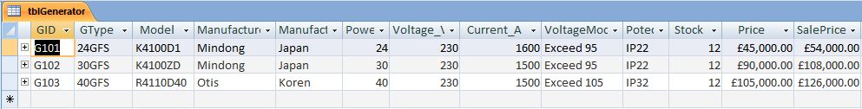

Record Deleted from Database

Fig 4.30

Data Search Screenshots

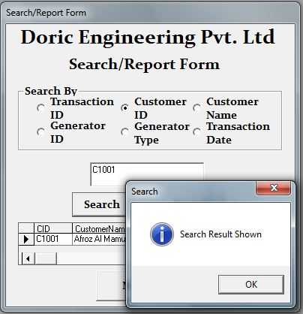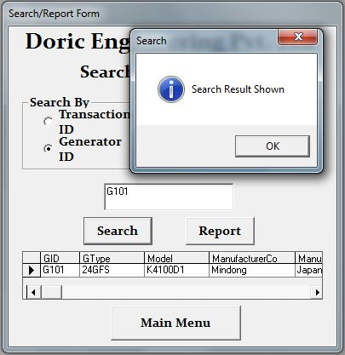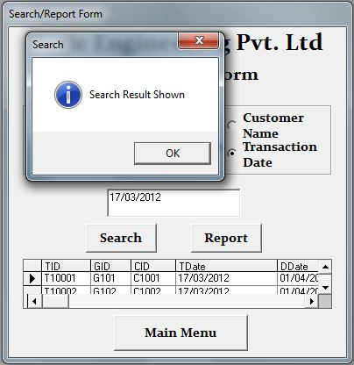

The option button is used to select the search criteria (Customer ID in the Customer table)

The text box is used to enter the search "key words"

The option button is used to select the search criteria (Generator ID in the Generator table)

The text box is used to enter the search "key words"

The option button is used to select the search criteria (Transaction Date in the Transaction Table)

The text box is used to enter the search "key words"

Fig 4.31

Fig 4.32

Fig 4.33

Data Report Screenshots

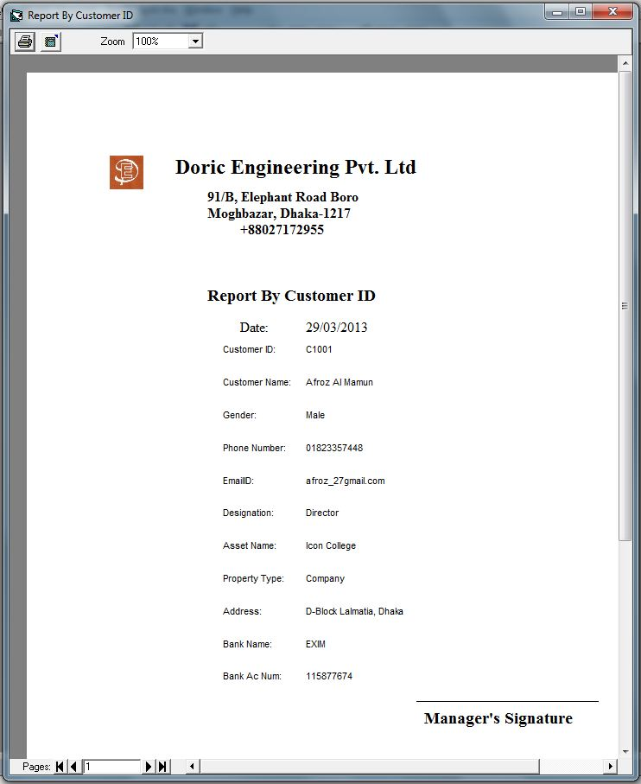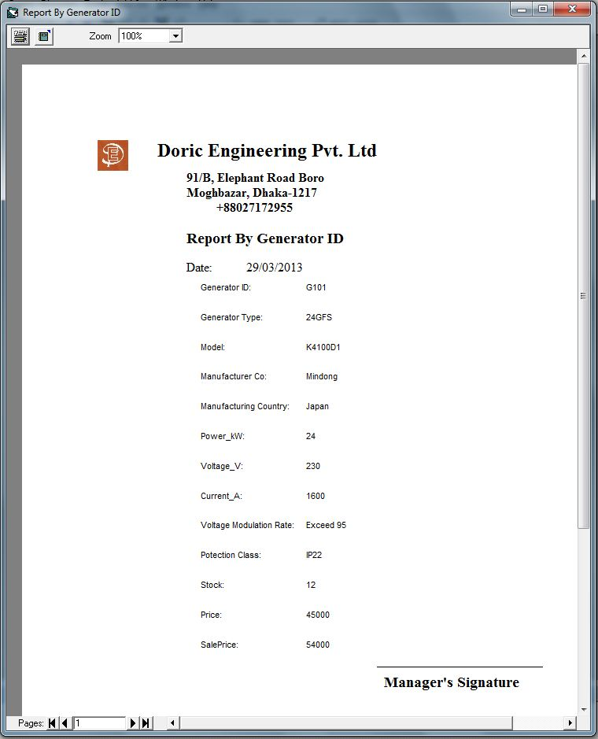

This report is generated by the report criteria - Customer ID in the Customer Table

This report is generated by the report criteria - Generator ID in the Generator Table

Fig 4.34

Fig 4.35

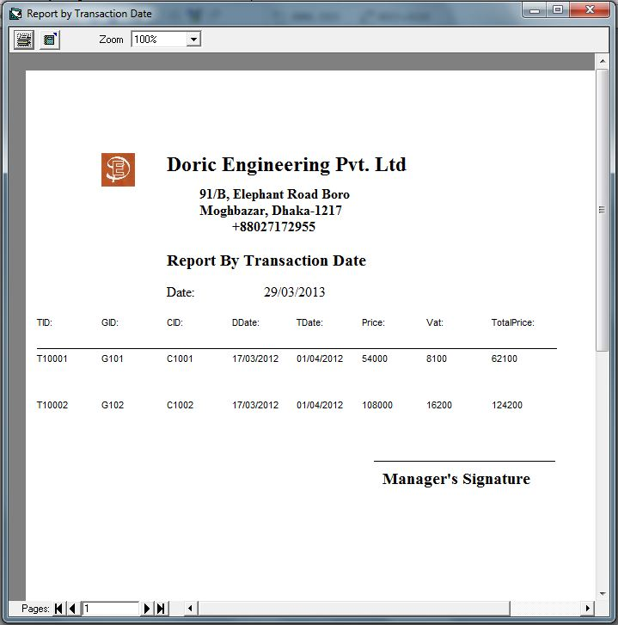

This report is generated by the report criteria - Transaction Date in the Transaction Table

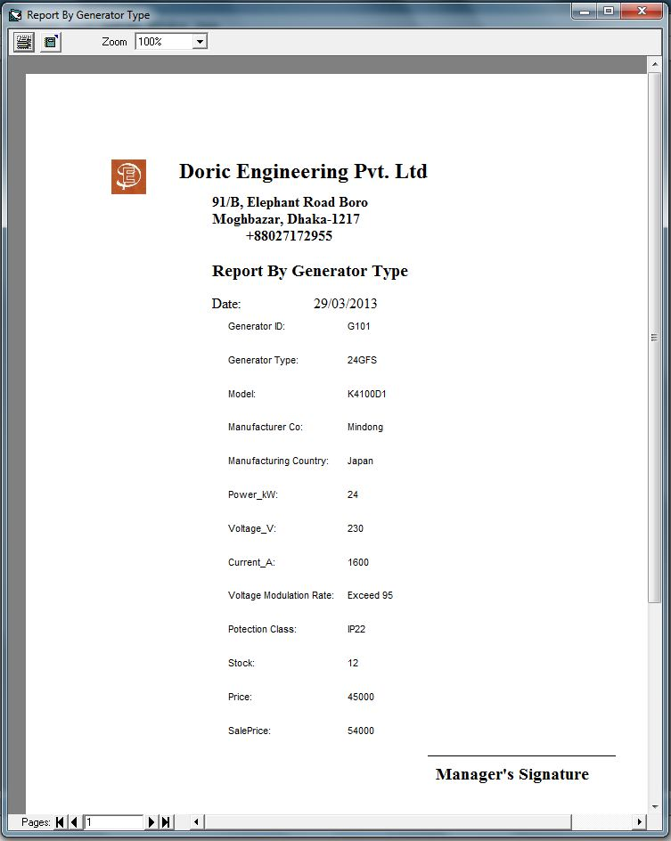

This report is generated by the report criteria - Generator Type in the Generator Table

Fig 4.36

Fig 4.37

Form Working

Transaction Form

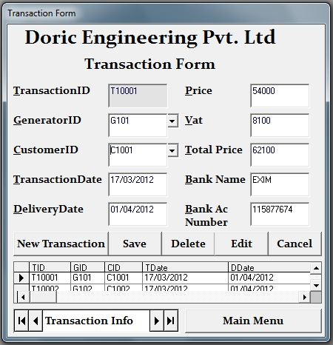

Auto generated Transaction ID

Calculated from the data in text box - txtPrice"

Data is inputted from the Data Combo - "dcmbCustomer" which is connected to the Customer Table by the Adodc - "adcCustomer"

Extracted from the Customer Table, from the record related to the Customer ID

Automatically inputs the current date

Calculated from the data in text box - txtTdate"

Data is inputted from the Data Combo - "dcmbGenerator" which is connected to the Generator Table by the Adodc - "adcGenerator"

Fig 4.38

Customer Form

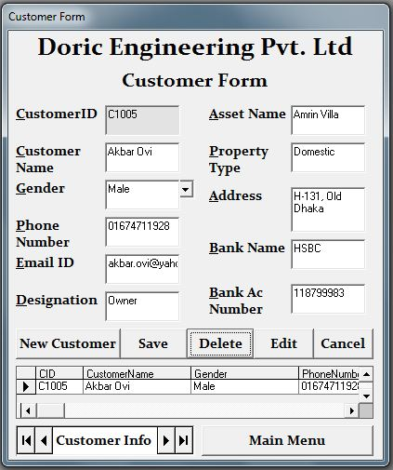

Auto generated Transaction ID

Rest of the fields are manually inputted

Fig 4.39

Generator Form

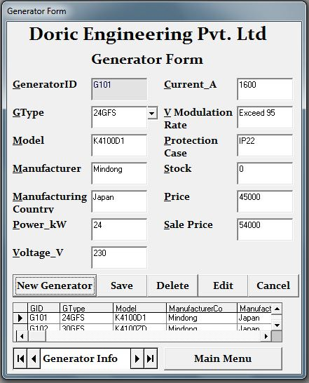

Fig 4.40

Auto generated Transaction ID

Rest of the fields are manually inputted

Calculated from the data in text box - txtPrice"

System Security (Co.7)

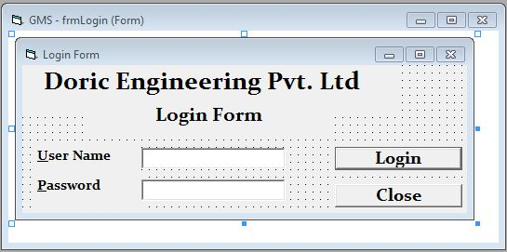

Fig 4.41

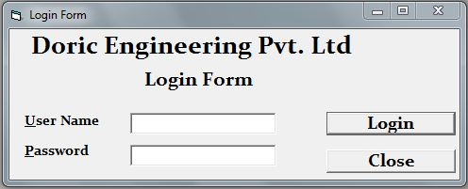

Fig 4.43

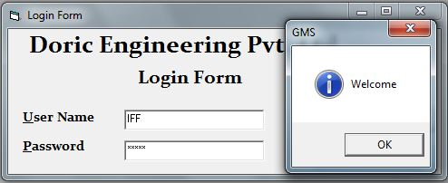

Fig 4.44

This is the design of the Login Form

This is the Login Form when opened

A welcome message is shown when correct User Name and Password is inputted

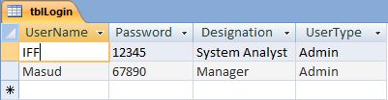

Fig 4.42

Only the users who are registered in the database can access software

Fig 4.46

Fig 4.45

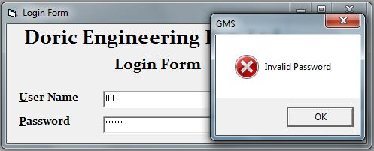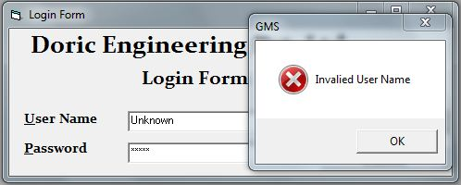

An error message is shown if the User Name that is inputted is invalid

An error message is shown if the Password that is inputted is invalid

How the Security System functions

The security system uses a User Name (User ID) and Password system to allow access to the software to only authorized personnel. As the software is not installed in the company's computer and is still being tested, I am using a demo user name and password to see if the security system is functioning properly or not. The User ID and Password check refers to the data that is stored in the database for cross matching.

**15. Test Results**

Transaction Form

|  |  |  |  |  |  |  |
| --- | --- | --- | --- | --- | --- | --- |
| Field Name | Test Data | Data Type | Validation | Expectation | Actual Result | Fig |
| TID | T10005 | Normal | Format Check | Accepted | Accepted | 4.01 |
| T100057 | Abnormal | Error Message | Error Message | 4.02 |
| Transaction Date | 23/03/2013 | Normal | Format Check | Accepted | Accepted | 4.03 |
| 23/03/13 | Abnormal | Error Message | Error Message | 4.04 |

Customer Form

|  |  |  |  |  |  |  |
| --- | --- | --- | --- | --- | --- | --- |
| Field Name | Test Data | Data Type | Validation | Expectation | Actual Result | Fig |
| CID | C1006 | Normal | Format Check | Accepted | Accepted | 4.05 |
| C10068 | Abnormal | Error Message | Error Message | 4.06 |
| CustomerName | Zeba Farzana | Normal | Length Check | Accepted | Accepted | 4.07 |
| Fayez Ahmed Jahangir Masud | Abnormal | Error Message | Error Message | 4.08 |
| EmailID | akbar.ovi@yahoo.com | Normal | Format Check | Accepted | Accepted | 4.09 |
| akbarovi71 | Abnormal | Error Message | Error Message | 4.10 |
| BankName | Exim | Normal | Presence Check | Accepted | Accepted | 4.11 |
| " " | Abnormal | Error Message | Error Message | 4.12 |
| BankAcNum | 118799983 | Normal | Type Check | Accepted | Accepted | 4.13 |
| 11879a | Abnormal | Error Message | Error Message | 4.14 |

Generator Form

|  |  |  |  |  |  |  |
| --- | --- | --- | --- | --- | --- | --- |
| Field Name | Test Data | Data Type | Validation | Expectation | Actual Result | Fig |
| GID | G104 | Normal | Format Check | Accepted | Accepted | 4.15 |
| G1045 | Abnormal | Error Message | Error Message | 4.16 |
| Model | K5100ZA | Normal | Presence Check | Accepted | Accepted | 4.17 |
| " " | Abnormal | Error Message | Error Message | 4.18 |
| Stock | 17 | Normal | Range Check | Accepted | Accepted | 4.19 |
| -1 | Abnormal | Error Message | Error Message | 4.20 |
| 1, 50 | Extreme | Accepted | Accepted | 4.21, 4.22 |

Errors found during testing

While performing the testing of the system I noticed some bugs. The following is about the error which I found and how I solved them.

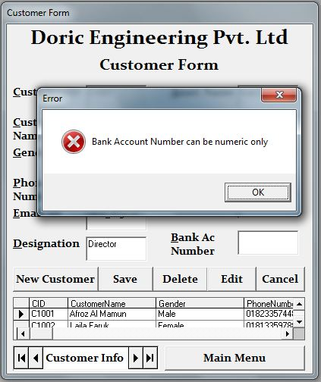

Fig 4.47

The above figures shows screenshot of the validation on the text box *txtBankAcNum*. It shows an errors message even though no data is not present, this happened when I accidentally pressed an extra backspace during the data manipulation of the Customer Form. The code was:

Private Sub txtBAcNum_KeyPress(KeyAscii As Integer)

If IsNumeric(txtBAcNum.Text) = True Then

Else: MsgBox "Bank Account Number can be numeric only", vbCritical, "Error"

txtBAcNum.Text = ""

txtBAcNum.SetFocus

End If

End Sub

The error with the code was it would show an error message for any sort of key, except numeric, even if those keys were the "enter" or "backspace" keys. It would also show an error once at first if numeric data was entered. Thus I understood out that the code was under the wrong event. So I changed the code from the " txtBAcNum_KeyPress(KeyAscii As Integer)" to the " txtBAcNum_LostFocus()"

The following shows the corrected form of the code:

Private Sub txtBAcNum_LostFocus()

If IsNumeric(txtBAcNum.Text) = True Then

Else: MsgBox "Bank Account Number can be numeric only", vbCritical, "Error"

txtBAcNum.Text = ""

txtBAcNum.SetFocus

End If

End Sub

I also faced another problem. When I set cursor focus on text box *txtBankAcNum* (in the Customer Form) keeping the text box *txtBankName* (in the Customer Form) empty, I found out that no error message was shown. I faced the same problem with text box *txtModel* (in the Generator Form), that it did not show error message when I set focus to other textboxes keeping it bank. The code for the txtBankNamewas:

Private Sub txtBName_KeyPress(KeyAscii As Integer)

If KeyAscii = 13 And txtBName = "" Then

MsgBox "Empty Field", vbCritical

txtBName.SetFocus

ElseIf KeyAscii = 13 Then

txtBAcNum.SetFocus

End If

End Sub

So I identified that the validation would only work if I pressed the "enter" key while my cursor key is focussed on that text box. So I corrected the error and made the validation universal, that it would show "error message", whenever I will change the cursor focus while keeping it blank. I did it by changing the event from “txtBName_KeyPress(KeyAscii As Integer)” to “txtBName_LostFocus()” and by editing the code to meet the new correction. The following shows the corrected code:

Private Sub txtBName_LostFocus()

If txtBName = "" Then

MsgBox "Empty Field", vbCritical

txtBName.SetFocus

End If

End Sub

I did the similar thing with the text box txtModel. Its code was:

Private Sub txtModel_KeyPress(KeyAscii As Integer)

If KeyAscii = 13 And txtModel = "" Then

MsgBox "Empty Field", vbCritical

txtModel.SetFocus

ElseIf KeyAscii = 13 Then

txtMan.SetFocus

End If

End Sub

I changed the the event from “txtModel_KeyPress(KeyAscii As Integer)” to “txtModel_LostFocus()” and by editing the code to meet the new correction. The following shows the corrected code:

Private Sub txtModel_LostFocus()

If txtModel = "" Then

MsgBox "Empty Field", vbCritical

txtModel.SetFocus

End If

End Sub

I faced another problem with the stock management. Whenever I would save the record in the Transaction Form, a quantity of "1" would be subtracted from the stock in the Generator Table, even though no new generator was bought. So, I found out that the code needed some readjustments so that the software can function properly. The following is the old code:

adcTransaction.Recordset.Update

s=adcGenerator.Recordset.Fields("Stock").Value

s = s - 1

With adcGenerator.Recordset

.Fields("Stock") = s

.Update

End With

MsgBox "Record Saved Successfully", vbInformation, "Saved....."

The following is the new code that I added to the software different parts of the software:

Dim stockconf As Boolean

Private Sub cmdNewTransaction_Click()

stockconf = True

End Sub

Private Sub cmdSave_Click()

If stockconf = True Then

s = adcGenerator.Recordset.Fields("Stock").Value

s = s - 1

With adcGenerator.Recordset

.Fields("Stock") = s

.Update

End With

stockconf = False

End If

MsgBox "Record Saved Successfully", vbInformation, "Saved....."

End If

End Sub

**16. Technical Documentation**

By using the data in the technical documentation a system analyst can understand how the system works and can perform software updates and amendments. It contains an overall system flowchart, top-down design of the system, flowcharts of data manipulation, search, transaction processing. It also contains the file structure of different tables and relationship between the tables. It also contains the hardware and software requirement to use/update the current software.

Features of the New Software

* It provides a user interface to manipulate the data in the database such as adding, editing, and deleting).
* It provides a query interface to perform data search and report relating to the selected criteria, by inserting key words related to the criteria and requested data.
* It allows navigation to and from the different forms of the software by using a central Main Menu.
* It provides a security system so that only authorized people can login to the system.
* It provides validation for different sorts of data to prevent any errors.

I performed testing of the system using a test strategy and also showed the test results. To see them, check in testing phase (Pg 52-56, 66-67; Fig 4.01-4.22, 4.41-4.46).

To see the codes, see Coding (Pg 43-50).

Overall System Flowchart (Fig 5.01)



Top-down design of the new system (Fig 5.02):

To show a helicopter view of the new system and its processes



Other flowcharts for different processes:



Fig 5.03: Adding a New Record in Generator Table

Fig 5.04: Deleting a Record in Generator Table

Fig 2.06: Editing a Record in Generator Table

Fig 2.07: Searching a Record in Generator Table



Fig 2.08: Saving a Record in the Generator Table

Fig 2.09: Transaction Processing



Input Layout of the Transaction Form (Fig 5.09)



The input layout of the Customer Form and the Generator Form are similar to the input layout of the Transaction Form (Fig 2.10).

Output Layout of the Transaction Report (Fig 5.10)



The design output layout of the Customer Report, Generator Report, etc is similar to that of the Transaction Report (Fig 2.11)

Database Design:

To illustrate the database of the new system, showing tables and how data is stored with data type, field size and data format with examples. It also shows the relationship among the tables.

The designed tables are in the following page.

Transaction Table

|  |  |  |  |  |
| --- | --- | --- | --- | --- |
| Field Name | Data Type | Field Size | Format | Example |
| TID (Primary Key) | Text | 6 | T##### | T10001 |
| GID | Text | 4 | G### | G101 |
| CID | Text | 5 | C#### | C1001 |
| TDate | Date | 10 | DD/MM/YYYY | 17/03/2007 |
| DDate | Date | 10 | DD/MM/YYYY | 17/04/2007 |
| Price | Currency | Long Integer | £……….. | £50,000.00 |
| Vat | Currency | Long Integer | £……….. | £7,500.00 |
| TotalPrice | Currency | Long Integer | £……….. | £57,500.00 |
| BankName | Text | 15 | N/A | EXIM |
| BankAcNumber | Number | Long Integer | N/A | 115877674 |

Customer Table

|  |  |  |  |  |
| --- | --- | --- | --- | --- |
| Field Name | Data Type | Field Size | Format | Example |
| CID (Primary Key) | Text | 5 | C#### | C1001 |
| CustomerName | Text | 25 | N/A | Afroz Al Mamun |
| Gender | Text | 6 | Male/Female | Male |
| PhoneNumber | Text | 11 | N/A | 01823357448 |
| EmailID | Text | 30 | ….@..... | afroz_27gmail.com |
| Designation | Text | 15 | N/A | Director |
| AssetName | Text | 20 | N/A | Icon College |
| PropertyType | Text | 10 | N/A | Company |
| Address | Text | 40 | N/A | D-Block Lalmatia, Dhaka |
| BankName | Text | 15 | N/A | EXIM |
| BankAcNum | Number | Long Integer | N/A | 115877674 |

Generator Table

|  |  |  |  |  |
| --- | --- | --- | --- | --- |
| Field Name | Data Type | Field Size | Format | Example |
| GID (Primary Key) | Text | 4 | G### | G101 |
| GType | Text | 10 | N/A | 24GFS |
| Model | Text | 10 | N/A | K4100D1 |
| ManufacturerCo | Text | 15 | N/A | Mindong |
| ManufacturingCountry | Text | 15 | N/A | Japan |
| Power_kW | Number | Long Integer | N/A | 24 |
| Voltage_V | Number | Long Integer | N/A | 230 |
| Current_A | Number | Long Integer | N/A | 1500 |
| VoltageModulationRate | Text | 10 | N/A | Exceed 95 |
| PotectionClass | Text | 10 | N/A | IP22 |
| Stock | Number | Long Integer | N/A | 15 |
| Price | Currency | Long Integer | £……….. | £45,000.00 |
| SalePrice | Currency | Long Integer | £……….. | £55,000.00 |

List of Variables

|  |  |
| --- | --- |
| Variable | Purpose/Position |
| xTID | Transaction Form, used in auto ID generation for the Transaction ID |
| xCID | Customer Form, used in auto ID generation for the Customer ID |
| xGID | Generator Form, used in auto ID generation for the Generator ID |
| d | Used to hold the string command for the delete function, in Transaction Form, Customer Form and Generator Form. |
| s | Used, in the Transaction Form, to hold the Numeric data of the “Stock” field in the Generator Table, subtract “1” from the stock and to update the “Stock” field. |
| g | Used to hold the string command for the Generator Type function, in Generator Form. |
| stockconf | Contains Boolean data, Used in Transaction Form for stock update. |

List of Formulas

|  |  |
| --- | --- |
| Field | Formula |
| Vat | txtVat = (Val(txtPrice) / 100) * 15 |
| Total Price | txtTPrice = Val(txtPrice) + Val(txtVat) |
| Delivery Date | txtDDate.Text = DateAdd("d", 15, txtTDate) |

The entity relationships in between the tables are as follows (Fig 5.11):



**Hardware requirement**

|  |  |  |
| --- | --- | --- |
| DEVICE | CONFIGURATION | Justification |
| Processor | Intel Core i3 (2.3 GHz) | For faster data processing |
| RAM | 2 GB | For storing more online application data temporarily |
| Hard disk | 500 GB | For storing more data on the database |
| DVD-ROM Drive | ASUS 52-X | For inputting data from optical disks |
| Input devices | Keyboard and Mouse | For manipulating/inputting transaction, customer, etc. details onto the database |
| Printer | Canon ip2772 inkjet | For printing transacting, generator, etc. reports |
| Monitor | 17” colour monitor | For viewing the running system |

**Software requirements**

There are many commercial software packages available to solve the drawbacks of the store. For example database software can be used to keep all the records of the store that will perform as the back-end and will also be used to store data. The front-end will be an interface created using a programming language. Both the database and the programming language will be used to establish the system, since they cannot be used alone and would easily carry out all the tasks required.

The options for the database software are:

• Microsoft Access

• Microsoft Excel

• Oracle

The options for the programming languages are:

• Visual Basic

• Quick Basic

Database Software:

|  |  |  |
| --- | --- | --- |
| Software | Advantages | Disadvantages |
| MS Access | 1. Easy to create a database.  2. Tables, forms, queries and report generating are easier by using wizard or design mode.  3. Easy to establish relationship between tables in a database. | 1. Can’t handle huge amount of data.  2. When access database file is used, it increases unnecessary size.  3. To solve a specific task, it needs  Visual Basic programming editor or script. |
| MS Excel | 1. Excellent program to create spreadsheet for various modelling and simulation.  2. It has numerous built in functions to solve the mathematical and logical problems.  3. It has different types of charts and graphs. | 1. User defined functions can’t be solved since all the functions are unalterable.  2. Does not support DBMS.  3. Does not create the attractive and user friendly interfaces to run the developed application program. |
| Oracle | 1. It handles huge amount of data.  2. Complex search and report generating can be done easily.  3. It has a strong and maximum data security facility to protect the data. | 1. It requires high skilled programming knowledge to develop the program.  2. It is expensive to afford.  3. It is difficult to program |

|  |  |  |
| --- | --- | --- |
| Software | Advantages | Disadvantages |
| Visual Basic | 1. It is very good application developer that comes with good number of useful tools and components.  2. It is easy and convenient to write program and debug, with it is instructions that is closer to English.  3. It has an attractive and a graphical user interface. | 1. Multiple projects cannot be opened or run in the same window.  2. The developer should have clear programming knowledge.  3. It needs high requirements as MS windows. |
| Quick Basic | 1. User defined functions can be solved.  2. Its syntax (instructions) is close to  English statement, so it is easy to understand.  3. It includes interpreter that converts a  written program into a compiled self | 1. It does not have the good and attractive interfaces.  2. Too many codes (instructions) have to be written to solve the problem. |

**Ideal software that can be used**

ORACLE 8i with Developer 2000 is very powerful to handle large amount of data which is very expedient. But it requires very high skilled and skilled programmer and also it is very expensive. Therefore I have chosen Microsoft Excel and Access.

**Best software to be used to solve the problem**

The database software that will be used would be Microsoft Access 2000 or higher. This will be used as data holder and the programming language would be Microsoft Visual Basic 6.0 (VB98) that will perform as the manipulator of data. It is wise to use both of these; since Access supports all the modules and Structured Query Language (SQL) required for developing the system and also it is less costly. Visual Basic will be used to create the interfaces, since it supports SQL for input and output of data to and from the database, as it will be connected to the database via Microsoft Jet Engine 4.0 using ActiveX Data Object (ADO) control.

**Justifications for writing a problem**

The tasks like validation checking, searching records and report generating would become handy only by a written program though programming language is a bit difficult to learn and utilize. So I used Visual Basic which is comparatively easier to write the program which has facilities that I would need to produce the software, as follows:

1. Its Graphical User Interface has a professional look but yet it is user-friendly
2. When the user writes an object’s name while programming, the programming editor provides the properties and methods automatically
3. Writing the program is done conveniently as the required tools and components are provided.
4. Visual Basic programming language allows modular programming, which increases the usability of programs as a common function.
5. Different types of colour codes are used to show the different modes of the program, that helps the programmer to know whether he is going in right way or not.

Moreover, any kind of calculation and checking can be performed. Additionally, the program would give proper security to the records by the use of passwords.

**17. User Guide**

Installing the software

1. Insert the disk which contains the software.
2. Install the software (Make sure to install in C:\Program Files).

If the software is not installed in drive C, then the following error message will be shown (Fig 5.12).

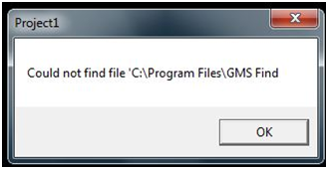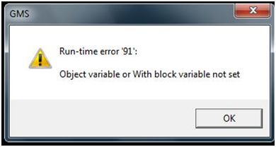

5.12

Running the software

1. After the software is setup, then the software can be used my using the following shortcuts, either by starting if from the Start Menu-GMS-GMS.exe or by using the desktop shortcut “GMS.exe”(Fig 5.13)
2. See the following procedures of the user guide to know how to use the different functions of the software.

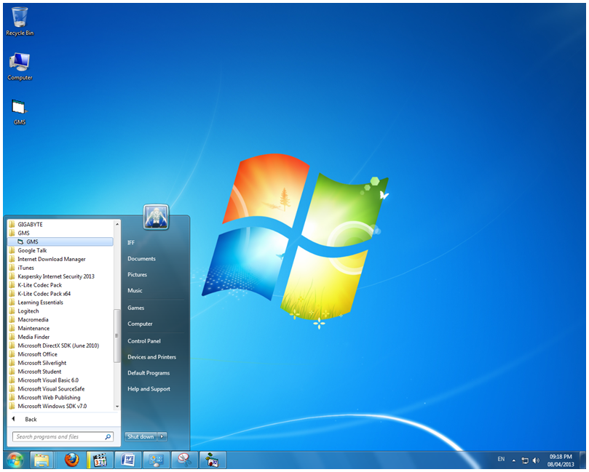

5.13

Security Form



Fig 5.14

This is the Login Form when opened

1

2

1

3

1

Tools of the Login Form

|  |  |
| --- | --- |
| Label | The function it represents |
| 1 | To navigate login to the system |
| 2 | To close of the software |
| 3 | To input the user name and password |

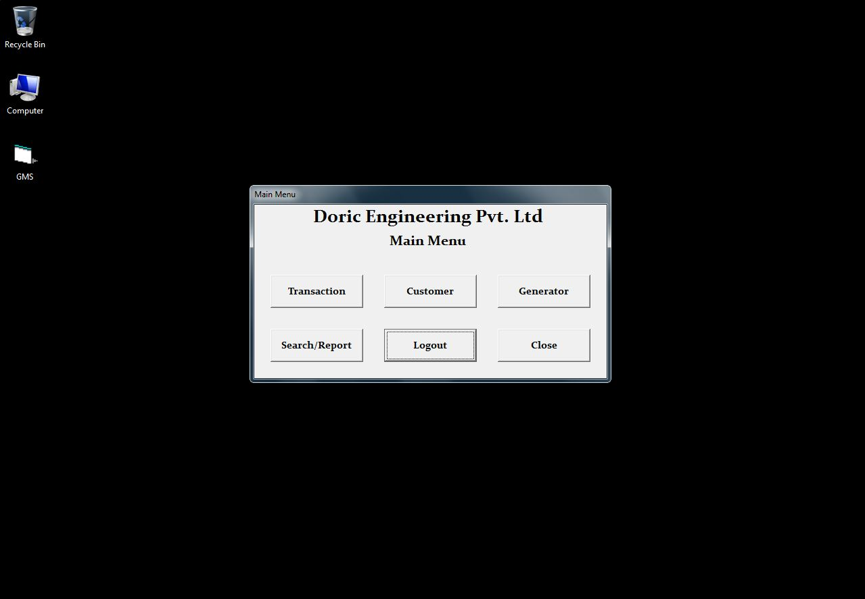

1

3

2

1

5

6

4

Fig 5.15

Tools of the Main Form

|  |  |
| --- | --- |
| Label | The function it represents |
| 1 | To navigate to the Transaction From |
| 2 | To navigate to the Customer From |
| 3 | To navigate to the Generator From |
| 4 | To navigate to the Search/Reprort From |
| 5 | To Log out of the software |
| 6 | To Close the software |

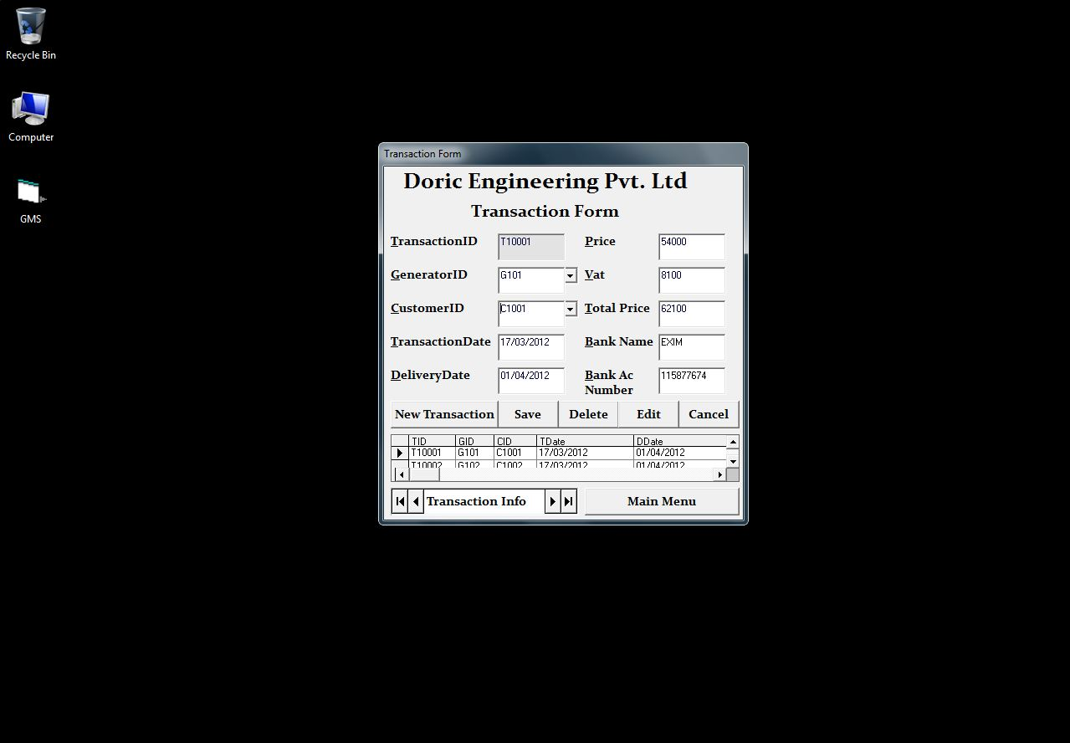

2

4

3

1

5

6

7

1

5.16

Transaction Form

Tools of the Transaction Form

|  |  |
| --- | --- |
| Label | The function it represents |
| 1 | To input data using a data combo list from the database |
| 2 | To add a new record |
| 3 | To save the record |
| 4 | To delete the record |
| 5 | To edit the record |
| 6 | To cancel the action |
| 7 | To show the database table |

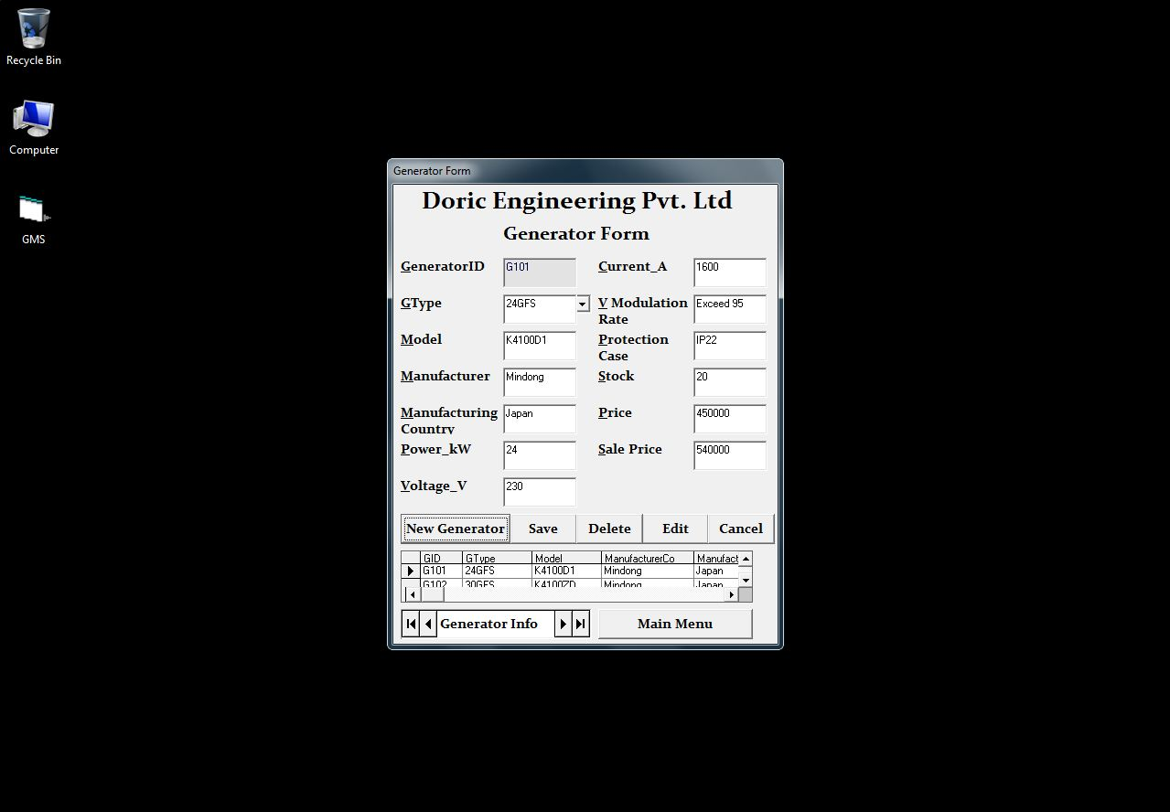

2

4

3

1

6

7

1

5

5.17

Generator Form

Tools of the Generator Form

|  |  |
| --- | --- |
| Label | The function it represents |
| 1 | To input data using a data combo list from the database |
| 2 | To add a new record |
| 3 | To save the record |
| 4 | To delete the record |
| 5 | To edit the record |
| 6 | To cancel the action |
| 7 | To show the database table |

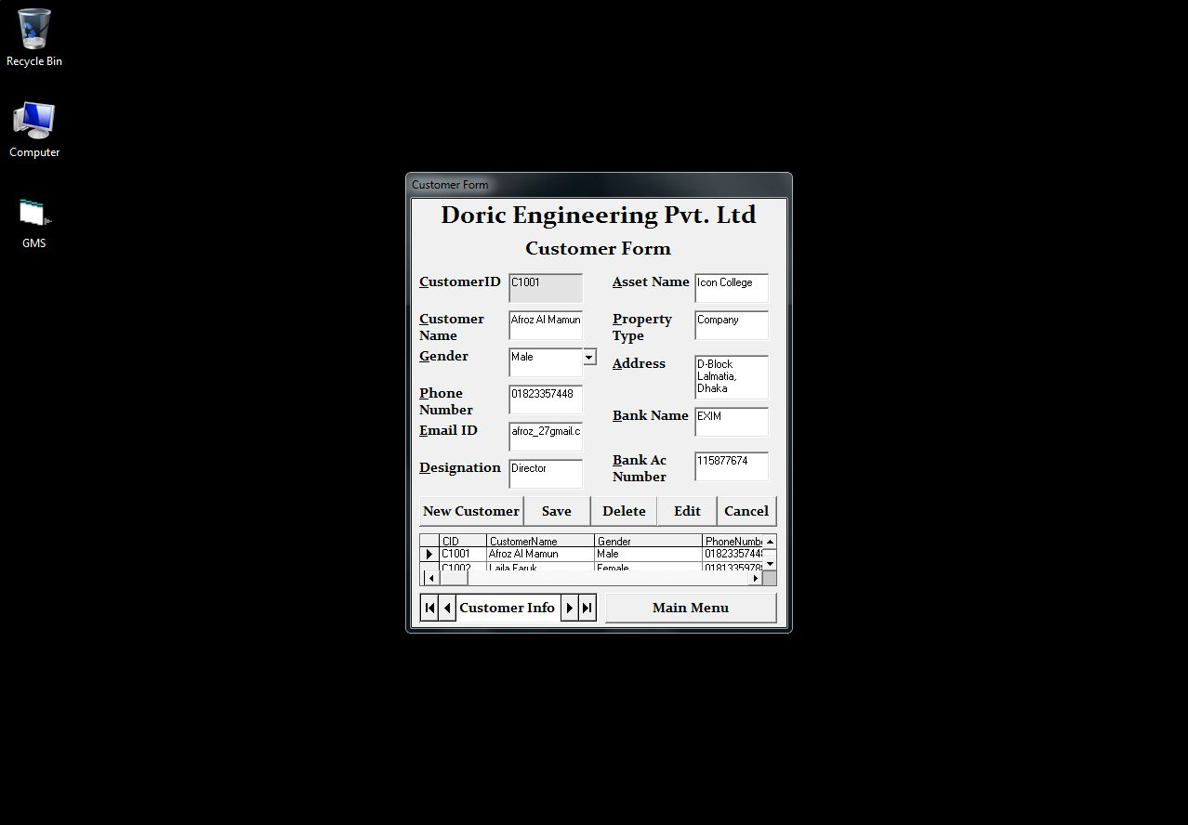

2

4

3

1

6

7

5

1

5.18

Customer Form

Tools of the Customer Form

|  |  |
| --- | --- |
| Label | The function it represents |
| 1 | To input data using combo list containing Boolean data |
| 2 | To add a new record |
| 3 | To save the record |
| 4 | To delete the record |
| 5 | To edit the record |
| 6 | To cancel the action |
| 7 | To show the database table |

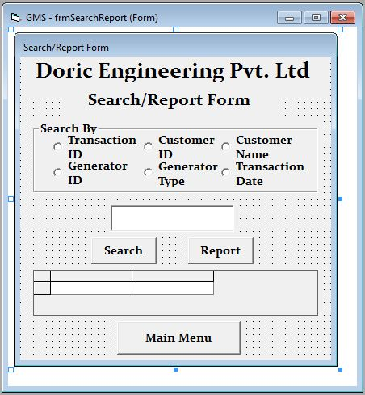

1

3

2

1

5

6

4

7

9

8

10

11

5.19

Search and Report Form

Tools of the Search and Report Form

|  |  |
| --- | --- |
| Label | The function it represents |
| 1 | To select search criteria “Transaction ID”” |
| 2 | To select search criteria “Customer ID” |
| 3 | To select search criteria “Customer Name” |
| 4 | To select search criteria “Generator ID” |
| 5 | To select search criteria “Generator Type” |
| 6 | To select search criteria “Transaction Date” |
| 7 | To input the search keyword |
| 8 | Outputs the search result |
| 9 | Outputs the report |
| 10 | Navigates to the main menu |
| 11 | Shows the search output |

To see how the reports look like check in the appendix, there I have given a hardcopy print out of all the reports.

The Demo CD

I have created a Demo CD which contains videos that will show different functions of the software. It contains a tutorial of how to perform all the documented functions of the user guide.

* how to login using authorized credentials
* how to perform all the data manipulation tasks in all the forms
* how to navigate throughout the entire software
* how to perform search and report

**Hardware requirement**

|  |  |  |
| --- | --- | --- |
| DEVICE | CONFIGURATION | Justification |
| Processor | Intel Core i3 (2.3 GHz) | For faster data processing |
| RAM | 2 GB | For storing more online application data temporarily |
| Hard disk | 500 GB | For storing more data on the database |
| DVD-ROM Drive | ASUS 52-X | For inputting data from optical disks |
| Input devices | Keyboard and Mouse | For manipulating/inputting transaction, customer, etc. details onto the database |
| Printer | Canon ip2772 inkjet | For printing transacting, generator, etc. reports |
| Monitor | 17” colour monitor | For viewing the running system |

**18. Evaluation of the new system**

|  |  |  |
| --- | --- | --- |
| Objectives | Evidence | |
| Page | Fig |
| Co.1 User interface |  | 4.38 - 4.40 |
| Co.2 Data storage |  | 3.02, 3.04 |
| Co.3 Avoid data duplication and redundancy |  | 3.05 |
| Co.4 Auto ID Generation |  | 3.01, 3.03, |
| Co.5 Validation |  | 3.18 - 3.21, 4.01-4.22 |
| Co.6 Search & Reports |  | 3.16-3.17, 4.31 |
| Co.7 Security |  | 4.41-4.46 |

The new software was able to accomplish all the Computer Objectives that were set. After two weeks, I received a letter from the company's Managing Director, where he stated his feedback of the new software. Then after another one week, he sent a letter regarding some new developments which he would prefer.

In his first letter, he said that he was very pleased with the software. He mentioned all the business objectives being fulfilled and that the customers are now more satisfied with the company’s service.

In his second letter, he mentioned some changes he would prefer and he wanted some additional features to be included into the software. The following are a summary of the Managing Director’s second letter:

1. He wished to add new users and also allow existing user to change the password.
2. He wanted the employee’s payroll system to be computerized and added to the software.
3. He wanted to set the sales price independently during the transactions.

To see the letters, check in the appendix.

**19. Suggested Improvements**

The new system being very rigid prevents the employee for doing certain things and limits their rights of using the software. One of that is setting the delivery date and the selling price according to the company’s convenience. There are also some other case where the software could be improved.

So I created a set of ideas for showing the possible improvement of the evaluated system. The following illustrates these ideas:

* The security system could be improved by adding new functions such as new user “sign up” and allowing old users to change their password according to their wish, making it more flexible.
* The transaction form could be improved by allowing the sales employees to set the sales price according to their wish, which gives more credibility to the employees.
* A new form could be added to manage the payroll of the employees, which would be only accessible by the manager and higher authorities only.
* The input of the product ID could be done by using Barcode reader and setting the product id as the barcode. This would enhance the input of data and would remove the chance of input errors.
* More validation checks could be added to further reduce the chance of any error.
* More criteria for doing search and report could be added.